# Table of Contents

Table of Contents 1

SUMMARY 2

INTRODUCTION 2

WHAT ARE THE MOTIVATIONS BEHIND OUR IDEA? 3

WHAT IS STUDYMATE? 3

WHAT DOES STUDYMATE PROVIDES TO USERS? 3

WHY IS IT A GOOD FIT FOR CURRENT MARKET? 4

HOW CAN IT BE USED AS A REAL LIFE APPLICATION? 4

ADVANTAGES OF STUDYMATE? 4

IMPLEMENTATION: 6

AWS COGNITO AND CERTAIN MICROSERVICES : 6

AWS LAMBDA AND LAMBDA FUNCTIONS : 10

AMAZON CLOUDWATCH 13

AMAZON API GATEWAY : 17

AMAZON DYNAMO DB 24

EC2 INSTANCE : 29

What is StudyMate Meeting? 33

Services used to implement StudyMate Meeting. 34

Server-Side Setup 35

How to use StudyMate Meeting? 39

**USER MANUAL…………………………………………………………………………………………………... 41**

**RESPONSIVE DESIGN…………………………………………………………………………………………... 49**

Oliver - Chatbot using Google Dialogflow. 50

Implementation 50

FAQ Questions 53

# SUMMARY

The project, titled – StudyMate, is basically a web application that helps university students or working professionals to connect to likeminded people to build a great professional network. The demographic of target users consists of high school students who would be starting their university life soon, current university students willing to build a network around and outside of their university and final year university students who are looking to grab their dream job but does not have the right mentors or the required network to approach relevant organizations. Not only that, but it can also help current working professional who are looking for a job change or someone looking to make new friends in their current organization. We believe that someone can certainly get into their dream university or get their dream job if they are enlightened. StudyMate offers a wide range of services to its users. The goal of our application is to connect users across the group based on the university or organization of their choice, provide them with a platform to discuss about ideas or queries that they may have, stay updated with the current job market, get some insights about the university or corporate life, and overall build a better career. We believe that a loss of connection between current university students and their university alumni can probably close doors to some opportunities that they might be able to make the most of it with great network of people around them. These are some issues that we all have faced at least once, be it wondering about the university to join after our high school or taking up a job just after university or continuing working in an organization that does not align with our goals. It’s a platform that can also help in building a better open-source community as you have public and personal chat rooms where you can discuss your ideas, start implementing them and help each other out to get better not only professionally but personally as well. Though we are still in alpha phase, but we believe StudyMate is one platform looking to solve all such problems and we are looking to bring “one big change”.

# INTRODUCTION

StudyMate, a web application focussed on targeting a wide diversity of students and working professionals with the goal of helping each other out to not only grow professionally but individually as well and build a better community. StudyMate focusses on helping users to build a better network by providing certain services that help users identify their dream university or dream job based on personal experiences of other users, present all around the globe. It provides you with multiple chat rooms, the public chat rooms where a person can just virtually hangout with their “Study-Mates” or the private chat rooms where a person can schedule a personal meet up to clear certain queries, hold a career building workshop or provide a road map to other users by sharing their experiences. StudyMate helps you keep your profile updated around your network that helps them make most of the opportunities. It offers you a quick search feature, through which you can search for users based on university or organization. Do want to get into Stanford University? We know it’s not easy to get into your dream university but search for it through our platform and you can certainly find a whole lot of people pursuing their higher education at Stanford, take a step forward in your career and connect with them to get enlightened. Do you want to work at Google? We know it is not easy to land your dream job but search for it through our platform and you can certainly find a whole bunch of people working at Google who might be willing to share their experiences and help you in having a goal-oriented roadmap. That is being said we provide great customer services, be it our virtual assistant, Oliver, that can certainly answer some of your questions that you might have, or our FAQ page that already answers some of your questions. We are in our alpha phase and certainly looking to add on better features, ranging from adding a financial model by having our own crypto currency or letting users build their own profile through our platform and a whole bunch of other features. So, why not just stick around?

# WHAT ARE THE MOTIVATIONS BEHIND OUR IDEA?

The lack of communication amongst the university students or between students and their university alumni makes it difficult to survive all the years of university, given it could be the most crucial phase of your life, and might become a barrier in your professional and as well as personal growth. Be it a student in his/her first year, who is a bit lost and does not have much idea about how to make the most of his/her university life or a final year student, who is all anxious about taking his/her next career step by landing a job that aligns with his/her goals. This could even be for a working professional who is stuck at a job that does not align with his goals or a job which he/she doesn’t look forward to doing every other day and willing to take a jump in his career by switching to his/her dream job, or just a working professional willing to make new friends at his/her workplace.

This certainly made us believe that this world does need a platform, that is easily accessible, doesn’t cost you anything, rather might even help you in making some pocket money in the future, connects you with people around the globe and helps you in landing your dream university’s offer letter or your next dream job. StudyMate has a way out!

# WHAT IS STUDYMATE?

As already discussed, StudyMate is a web platform, currently in its alpha phase but fully functional, that helps people connect across the globe with major focus of connecting students from universities or connecting someone with their university alumni. It also focuses on helping working professionals out by helping them build a better network that might let them take a step forward in their career. You can certainly get into your dream university or get your dream job if you are enlightened. StudyMate offers you certain features that lets you search for the users all around the globe, be it someone from the university you're willing to take admission in or someone from your dream workplace. It also lets you build a network with your university’s alumni or current students and help you in getting connected with your acquaintances from your workplace. There are certain services that we offer with a whole bunch of features waiting for you to make the most of. We believe in bringing a “one big change” to your university and professional life.

# WHAT DOES STUDYMATE PROVIDES TO USERS?

There are a whole bunch of services that StudyMate offers in its alpha phase. We focus on solving the challenges users face in their university or professional life. We are looking to target a diverse user group, be it a 18 year university student or a 30 year old working professional. StudyMate offers you services that you can make use of at least in your adulthood. These services include:

* It lets you hang out with your “study-mates” virtually through the web platform that we provide. The public channel can help you use a meeting platform, be it audio, video or plain text chats, to connect with your study mates, get your queries answered, build a better network, work on projects together and a whole lot of other possibilities. Found someone and looking to share thoughts, use the individual meet instead. You can share your content using the screen share provided in the public or individual virtual meeting.
* We focus on letting you build your network by keeping you and your profile updated. Keeping your profile up to date is one of the most important aspect to survive in the professional world. Make sure you use the email you signed up with before making any real time updates. Use this feature to keep your current university or your current workplace updated. It can be the most important aspect to have your details updated to best reflect your professional experience. This will let you and the whole bunch of other users to make the best use of StudyMate.
* We focus in providing you a great search API that lets you search for the users, all around the globe, based on a particular university or organization. Are you a student willing to go for higher studies and cannot figure out which university could be the best fit? You can connect with your university alumni and learn from their experiences to make the best use of your student life. Are you a working professional or a final year university student and looking to get into your dream organization? Search users from organization and StudyMate has it all figured out for you!
* We believe in providing an overall great experience to our services with a good customer support. Anyone can get curios when switching to a new platform specifically when you've whole bunch of other tasks could be challenging. We know it and thus provide you with your virtual assistant, Oliver, who helps you provide a virtual tour of StudyMate or helps you by resolving your queries by providing you a text-based FAQ channel. Some popular questions include What is StudyMate? Where can I find people? Can I find people from my University? Can I find people from my organization? How to keep my profile updated? How does chat rooms work? You should always explore more!

These are some of the services that we provide to our users and we are working hard to add a lot more of them. This can certainly help anyone build a better network or connect with people around the globe to grow professionally and personally.

# WHY IS IT A GOOD FIT FOR CURRENT MARKET?

As we have already discussed about the use cases, by using our portal users can make use of all such features that StudyMate provides to take a step forward in their professional career. There are not many applications in the market that lets user find people from a particular university or a particular organization and even allow them to interact with each other, ranging from one-to-one conversations to a whole bunch of people hanging out together virtually, there are not many applications in the market that provides such services. Also, we at StudyMate are planning to extend our financial model so the users, who are willing to help people out are paid some sort of our crypto currency that can be exchanged for real money after every fortnight. There is no application in the market that targets on helping user to connect with the best fit users based on their university or organization of choice. Also, there is no time limit in our chat rooms like some other services including and not limited to zoom, teams and so on unless you are willing to pay. Also, the platform provides a good UI with great customer support which includes your own virtual assistant, or some already answered FAQ’s and users do not need to spend a single penny and can access all the features, as there’s no premium accounts as such for now, like some other applications including LinkedIn. Thus, we strongly believe that StudyMate can bring a change in the current market and might be able to build a better community of working professionals and students.

# HOW CAN IT BE USED AS A REAL LIFE APPLICATION?

StudyMate is already in its alpha stage, thus can be considered as a real-life application which users from around the globe can access. We use Amazon Web Services for deployment and real time updates including Ec2 instances, DynamoDB database (NoSQL database), AWS Cognito for user authentication and a lot more which provides a hassle-free access to all the features to our users. As we are already keeping up with the market by using the best fit services that runs 24/7, anyone in the world can access the services without worrying about the server load thus providing a great client-side experience. As, we have most of our backend deployed on cloud, with our backend consisting of bunch of lambda functions using AWS Lambda integrated through AWS API Gateway, it makes it easy for users and for us to push quick updates to the production without worrying about the client side. The services that we use extend from using AWS to Google Cloud alongside a strong flask (A python framework) backend and a reasonably good UI which provide us with the opportunity for hassle free production and great team co-ordination. We believe we are already keeping up with the market by using the latest tech stack and thus StudyMate can be used as a real life application and probably can be the next big thing.

# ADVANTAGES OF STUDYMATE?

There are certain things to be considered when discussing about the advantages of a particular app. There are a few that we already talked about in the earlier sections and here’s a quick overview of it. Some advantages of using StudyMate includes:-

* With a bunch of options to connect with people, StudyMate, let’s you interact with multiple people at once without any restriction, though video, audio or plain text chat, in its public channel. You just need to add your name and you’re in. It also lets you share content by sharing your screen which certainly makes it easier to find solutions to your queries. If you find someone using “Find a Study Mate” feature, you can hold individual virtual meetups by sharing the meeting ID, and discuss about your ideas and help each other grow professionally. Give, there is not time constraint in the virtual meets and the public channel stays up 24/7, the services that we provide makes us standout from other platforms that provide something similar. Remember, you’re not asked to pay anything which makes it even better, specially for university students.
* We let you stay updated by allowing you the update your user profile, whenever you join a new university or take up a new job. Everything is based on “AWS” (cloud platform) so we provide real time updates. The moment you click on “update profile”, your data is updated in our database deployed on cloud so all the requests works well and thus we are capable of handling multiple requests at every “micro-seconds”. Real Time updates helps you keep your profile updated which is an important aspect to reflect on your business profile.
* We let you find users all around the group based on the university or organization of your choice. We have a strong backend, making use of bunch of lambda functions (AWS Lambda) integrated through AWS API Gateway which provides an almost serverless backend and hence it’s a whole lot faster to handle GET requests than what an API can provide. The moment you click on search button, we filter out the relevant details from our database deployed in cloud and provide you with a bunch of relevant details stating the user details with a great UI.
* We believe in providing efficient services to our customers and thus have a virtual assistant, Oliver, up for 24/7 that can handle your queries quite efficiently and provides you with a virtual tour of our portal. We also provide some already answered FAQs that can certainly help you in solving any queries that you might have. If still not satisfied, you’re provided with the email addresses of our developers, so you can send in your queries and we believe in resolving it quickly and efficiently.
* We use AWS Cognito for our authentication system, so you are provided with a Two-step authentication once you sign up for our services. Once you sign up, you’re asked to enter the code sent to your email to confirm your account so no dummy accounts can be created. You’re also provided with an access token once you log in that provides you with a unique identity into our portal. All the authentication is based on cloud with again backend deployed on AWS lambda and triggers added, that makes the whole user registration and login process quick and safe.
* We provide you with a great responsive user interface, so that you can operate our web portal on multiple devices without worrying about the design. This makes the user experience a whole lot better thus making it easy to make the most of our services. We continuously work on providing a better user experience and are always open to constructive opinions.

# IMPLEMENTATION:

There were certain steps involved to deploy our application using the latest cloud technologies and a certain flow was followed to develop the application from scratch. Here, a small guide to the implementation of some of the features using the latest cloud technologies will be provided, which if followed correctly, can help in achieving similar implementation:

## AWS COGNITO AND CERTAIN MICROSERVICES :

The first major task for us to configure user management for our web application. Given, how now a days many organization compromise with their user data and don’t provide relevant authentication that users deserve, we spent a lot of time to figure out the best way to provide the best fit authentication method, which uses latest cloud technologies so we decided to go with AWS Cognito:

We made use of Cognito to mainly provide server side authentication to our users. Cognito provides a large amount of authentication features, including two factor authentication, or account verification for first time users or using already existing OAuth Provider. We decided to concentrate on allowing the users to register to our web application, after which they are supposed to confirm their identity by entering the code sent to their emails, and hence can log in. This is because we didn’t wanted to compromise with user’s personal data by using any existing OAuth Provider like Google or Facebook. We also took care of user identities and hence used access tokens to provide unique identity to our user once they Log In to our website.

The implementation to achieve the above features involves following the relevant steps mentioned below :

* The first step is to create a user pool for your AWS Cognito setup, which is essential to keep user data for authentication purposes.
* To create a User Pool, you’re supposed to go to Amazon Cognito Console. You might need to provide your AWS credentials if you’re not already logged in.
* Once you’re redirected onto the Cognito User Pool, Choose the “Manage User Pool” button.
* You’ll see a “Create a User Pool” on top right corner of your screen, select the given button.
* On the next page, provide a name for your user pool and click on “Review Defaults” to save the name.
* Now next go on the “Attributes” tab, select “Email Address or Phone Number”
* At the bottom of the page select any attributes that you’ll like your user pool to have or click on “Add custom attribute” to create your own custom attributes. For this project, we chose “email”, “name” and “phone number” from the required attributes and created a couple of custom attributes name “university” and “organization”.
* Click on Next Step and from the tab menu select “Review”. After reviewing the details, click on “Create Pool” and your user pool is created which will now be used to save the details of new users.

Now, to follow up the process we are supposed to create some of the lambda functions to create some of the functionality.

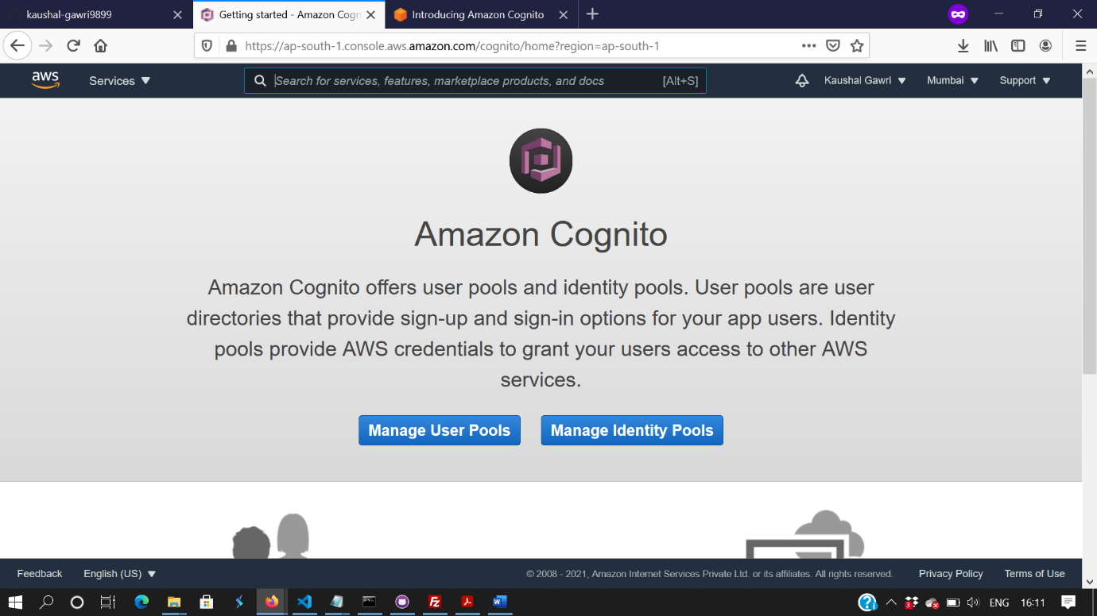

Figure 1 : Configure User Pools on AWS Cognito

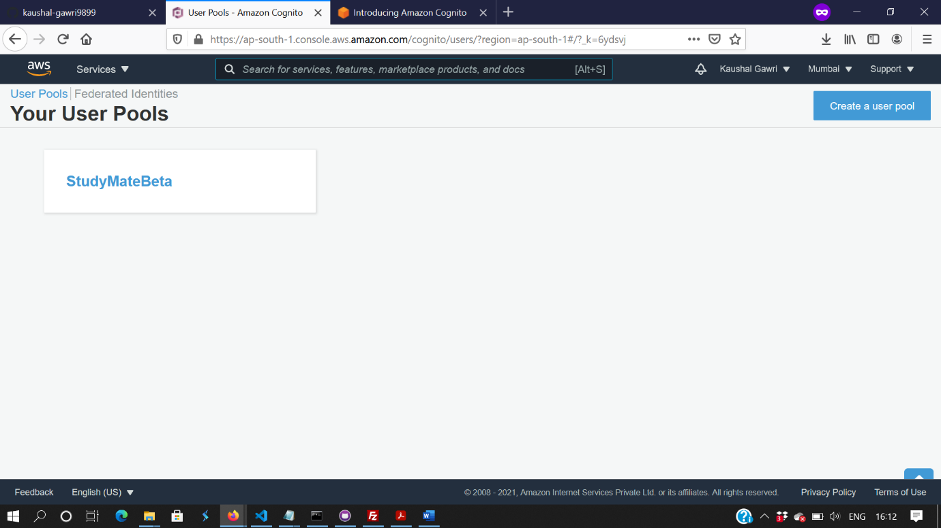

Figure 2: Create a new User Pool on AWS Cognito

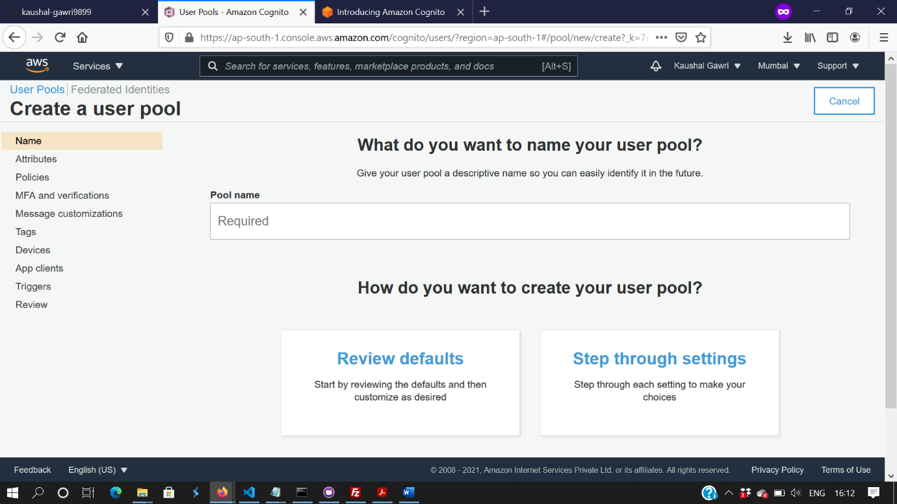

Figure 3 : Add a name to your user pool and save defaults

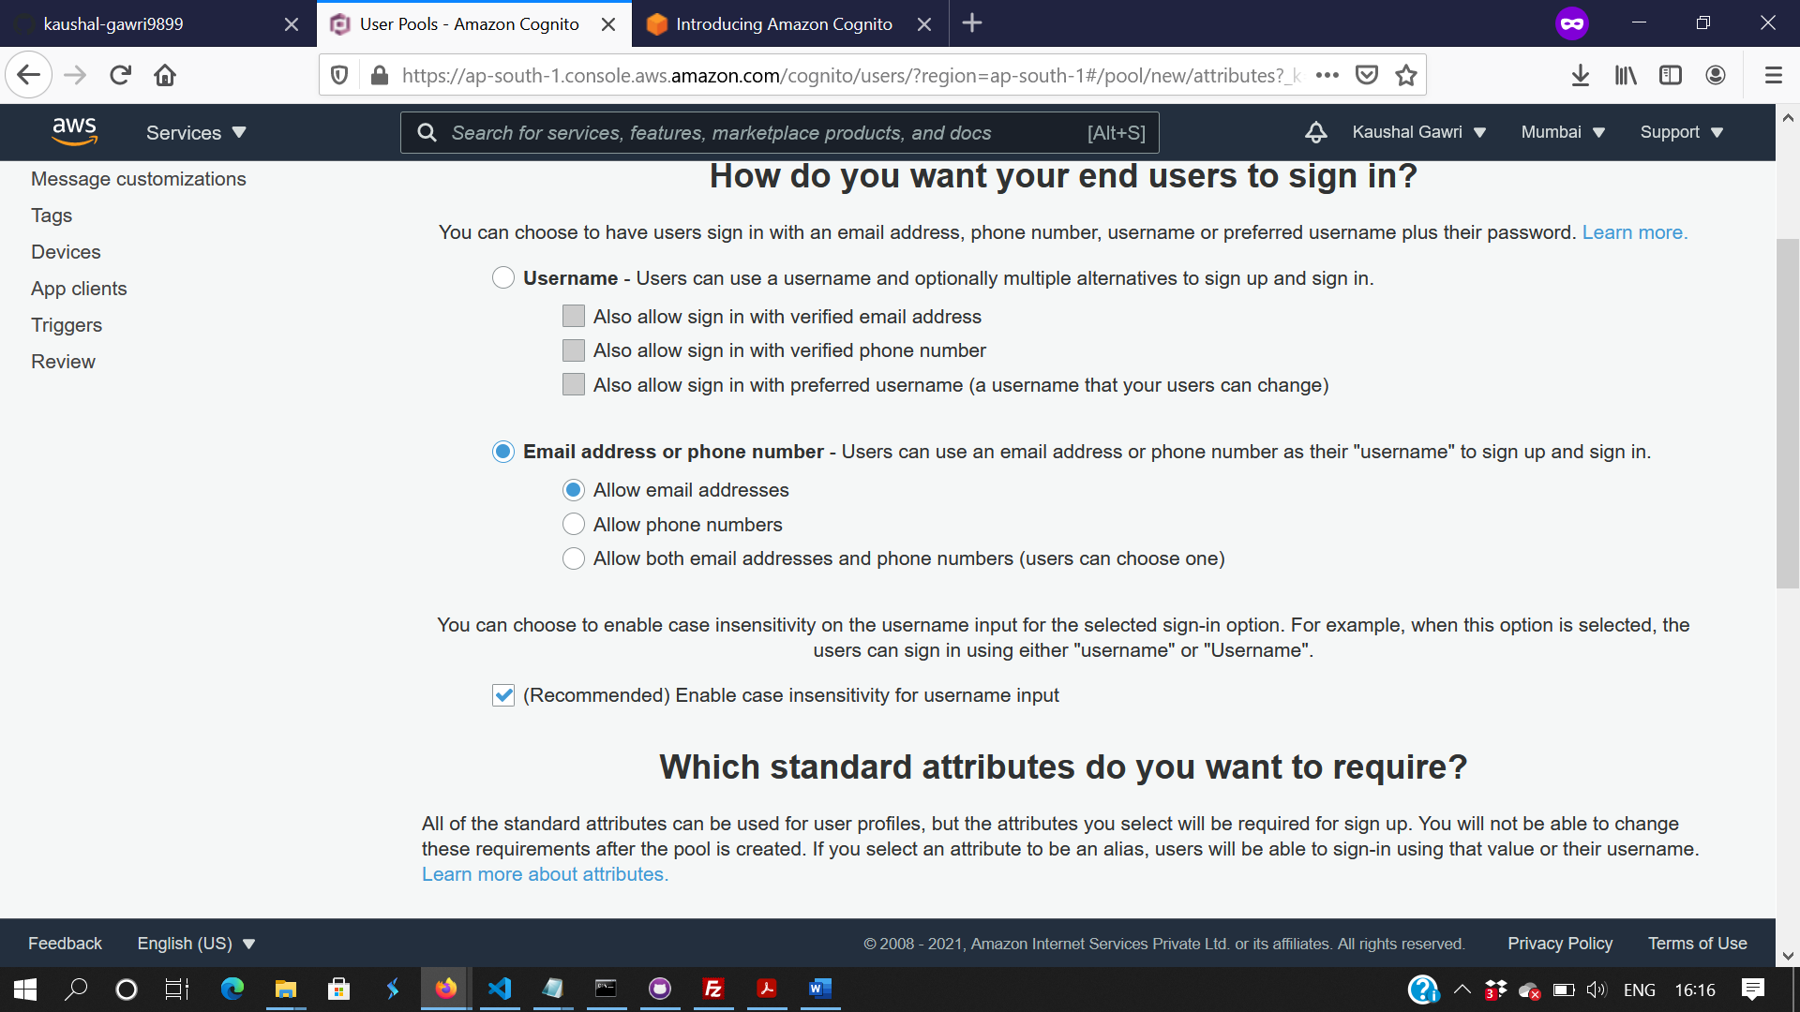

Figure 4: Configure Attributes of the user pool and add your custom attributes

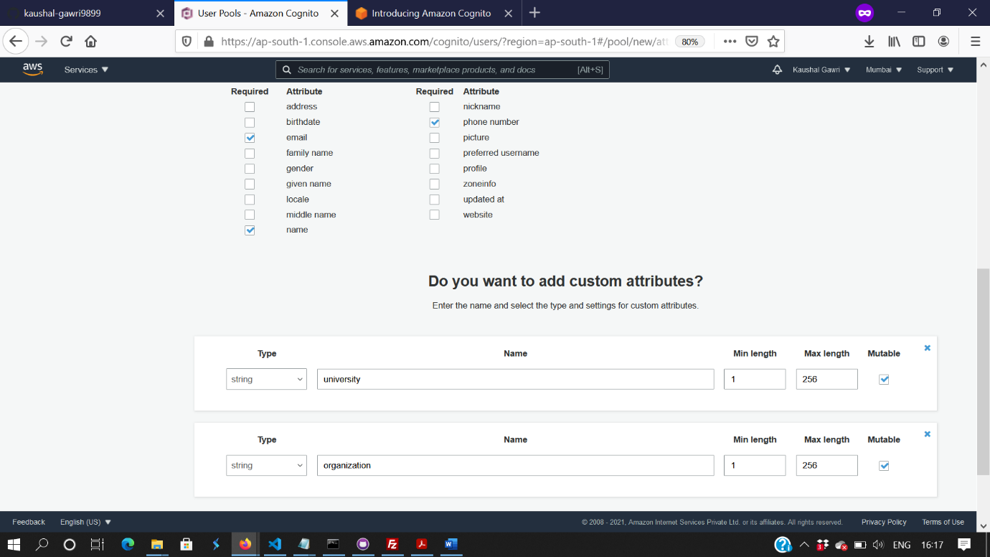

Figure 5: Configure Attributes of the user pool and add your custom attributes

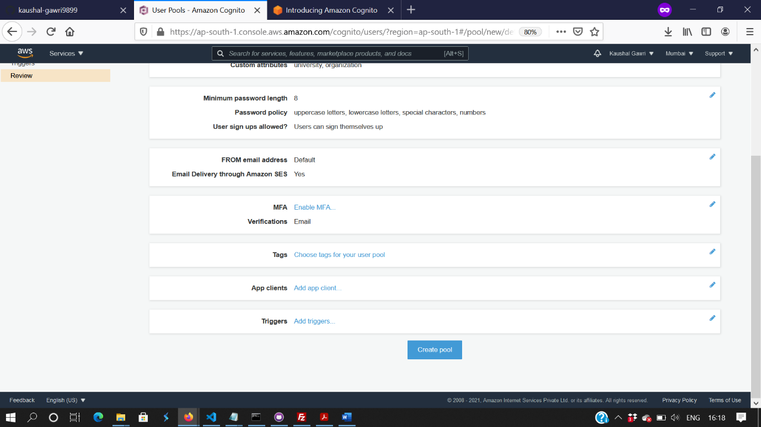

Figure 6: Click on Create Pool to finish creating you user pool

## AWS LAMBDA AND LAMBDA FUNCTIONS :

To configure user authentication in our system using AWS Cognito we first need to create certain lambda functions as a serverless backend, that in turn takes care of the whole process of user authentication ranging from user registration, confirm user registration and login process providing unique access tokens.

AWS Lambda is basically serverless compute service or a serverless backend that runs our code in response to certain events which can further help us in extending certain AWS services like AWS Cognito for user authentication, AWS API Gateway to handle HTTP requests majorly using a REST API in our case and Dynamo DB to create table or handle GET/POST requests from our table. It operates on AWS security so we don’t need to worry about adding security certificates for our backend.

AWS Lambda provides us with lambda functions, which once updated with our own code, can be ran as soon as they are triggered that improves the efficiency and helps managing certain tasks. As lambda functions are “stateless”, it can launch multiple copies of the function whose code we provided that makes the whole process even faster and we don’t need to worry about delays in our backend, which indeed would have been something to worry about if a custom API was used instead. Thus, AWS Lambda is a good choice depending on our use case.

The following lambda functions are required to create the user authentication flow :

* Creating a lambda function for new user registration (a.k.a signup). This will ensure that when a user tries to register on our web app, he/she first has to decide their primary email

id, which is accessible and a strong password of at least 8 character long consisting of lower case, upper case, numbers and special characters each. No email can be used by two different users and hence used as a primary key for our pool. The python code can be referred on the github repository provided.

* Creating a lambda function for confirming the user registration. This will ensure that once you sign up, you’re asked to enter a code send to the email id you provided. If the code entered matches what you were provided with, your sign up is confirmed and you’re redirected to the callback url which is your running web app.
* Creating lambda function to provide login for the users who have successfully completed the registration through AWS Cognito. This will ensure that the “password” and “username”(which is the user “email” in our case) that user entered matches the one already stored in user pool. Once the user successfully logs in, each user is provided with their unique access tokens that can be seen on the redirected url (callback url).

Following these steps will ensure that the user authentication is completed which can now be confirmed by testing it locally once the lambda functions are deployed . To create a lambda function follow the given steps :

* Navigate yourself to Lambda service on AWS Console and Click on “Create Function” at top left corner.
* Select author from scratch and input a name for your function, say for user sign up, name it as “signup”
* Select the programming language on which your lambda function should be based on. In our case, we would be using Python and Node.JS to develop some of the lambda functions.
* Select “Create a new role with basic Lambda permissions” and click on “Create Function”.
* We are provided with a built in lambda code, change the lambda code as per liking or refer the github repository provided.
* Make sure you click on “Save” to create your function.
* The next step we will do is to “Test” our code locally by passing a relevant JSON string, say for sign up function which should be in the form of :

{

"email": "you@you.com",

"name": "you",

"password": "You@1234",

"username": "you@you.com",

"phone_number": "+61450667343",

"university": "RMIT",

"organization": "student"

}

* Now, the next step involved is to test it locally by clicking on “Test” once the function is deployed(by clicking on “Deploy”).
* Follow similar steps to develop the lambda functions for all of the functionality mentioned above and test them locally by using the “Test” button given relevant json string is passed.
* To configure the testing, we would be using Amazon Cloud Watch that lets you see the output on the console which can be helpful for testing.

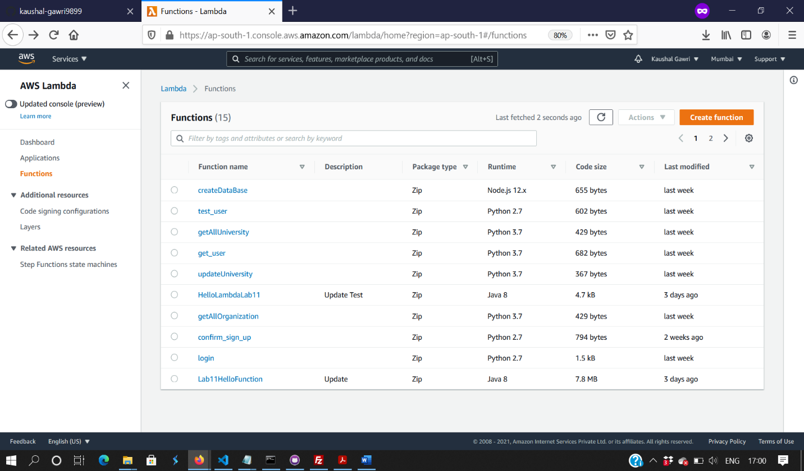 Figure 7 : Create a new Lambda Function

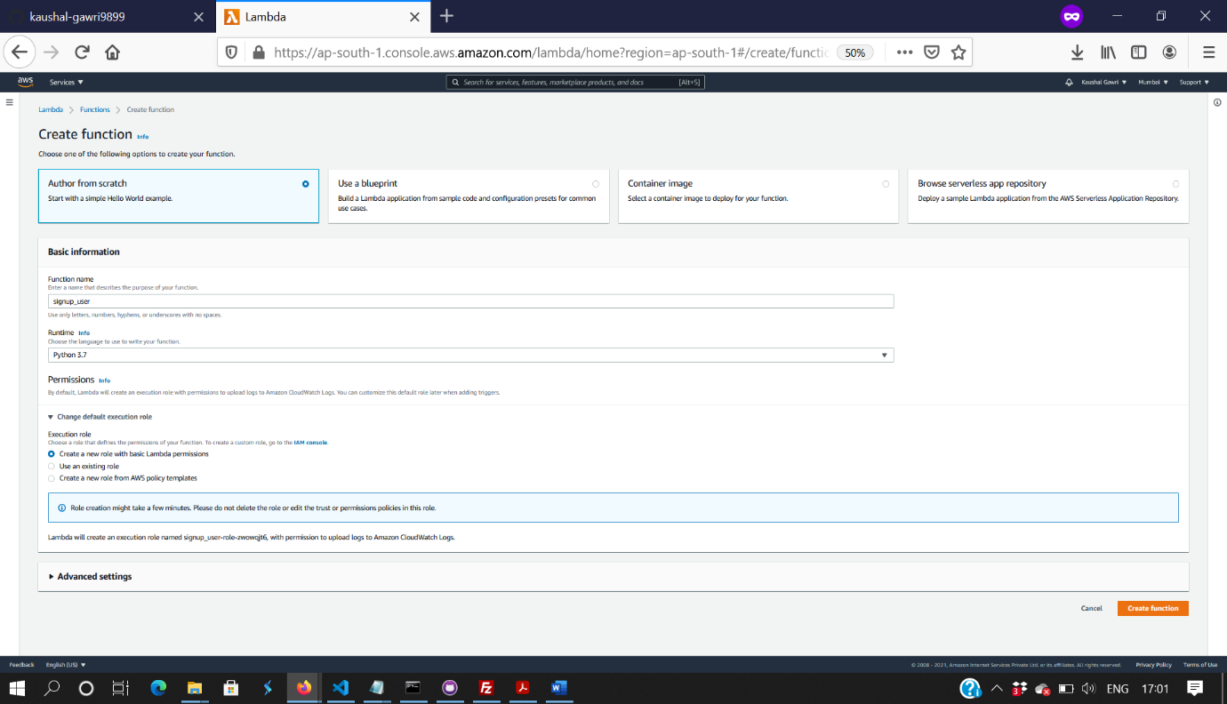

Figure 8: Configure Your Lambda Function to author from scratch

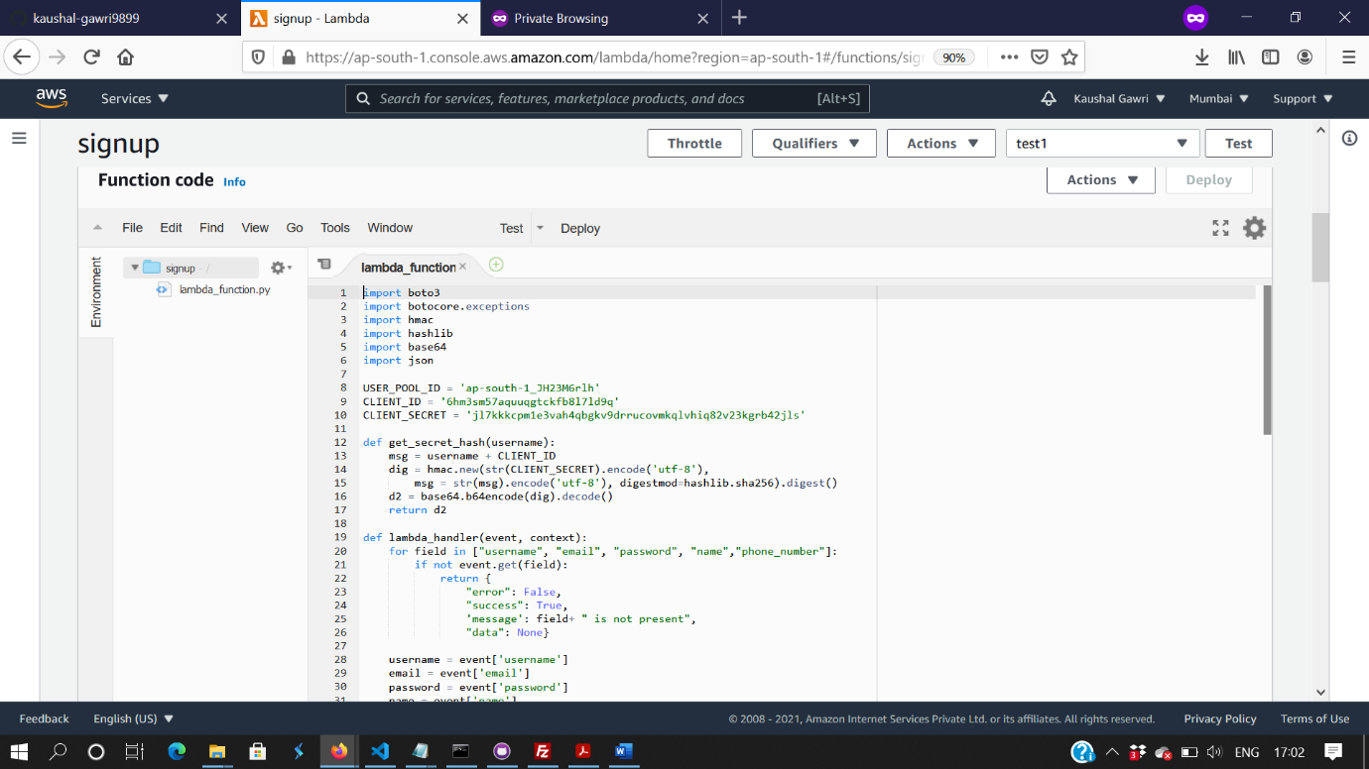

Figure 9: Add the following code for our sign up function

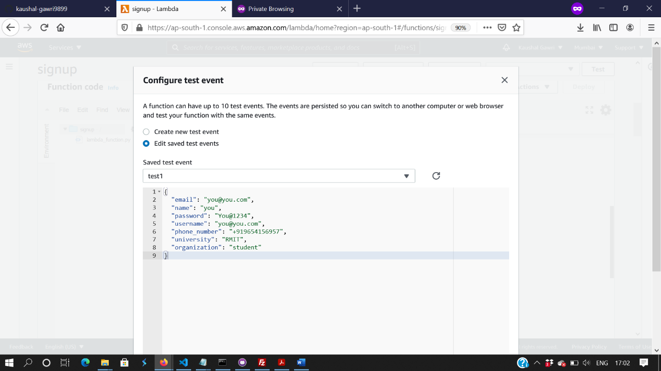

Figure 10 : Configure your lambda function test with similar JSON Strings

## AMAZON CLOUDWATCH

Cloudwatch, a monitoring service that provides us with data and insights to monitor our applications and infrastructure resources. The purpose of using cloudwatch while StudyMate was in development phase was to reduce the amount of time spent for debugging, which reduced to more than 60% once we got ourselves familiar with cloudwatch as we were able to now collect and access all the performances of the deployed lambda functions in the form of logs and metrics. It helped us in retrieving any exceptions or the responses that our lambda functions returned when invoked with the help of logs, that made it easy for debug any errors and format the responses the way we would like and thus overcoming the challenge of monitoring individual systems and APIs. It also helped in debugging any issues with the REST API that we will talk more about through the well formatted logs that it provides. We can use any of the 8 built in metrics for AWS lambda to detect errors.

The following steps were involved in debugging our lambda functions deployed on AWS Lambda with the help of CloudWatch :

* Search for CloudWatch Services on the AWS Console.
* You will be provided with a dashboard, and a tab menu on the left side of the screen.
* You can see the status of your services, like we used “Alarms” on the tab menu which displayed the status of our dynamo DB databases, that changes from Insufficient data to “OK” as more users engaged with our application.
* The major part of debugging was done through the “Logs” link provided on the left side of the screen.
* From the “Logs” Link, select the “Log groups” link which will redirect you to another page. Now, you’re provided with a list of lambda functions being used for your serverless backend. Select one of the functions that you want to debug or get an insight about some of the analytics like the number of times the function was invoked in last 1 hour.
* Now, you’ll be redirected to another page that displays the log streams of the function you chose which is arranged from latest call to the first. Click on the log stream you want to see logs for, say “getAllUniversity” in our case.
* You’ll be redirected to the another page that displays the response which will be useful for you to debug (as you can see we got an AccessDeniedException which specifies that this function requires you to have a special role to access DynamoDb database which we will set later on).

By following the above steps we can certainly make debugging on cloud a whole lot easier that will in turn increase your efficiency.

Now, it’s our turn to deploy our lambda functions at certain endpoints using various microservices to build a REST API. For this, we would be making use of AWS API Gateway.

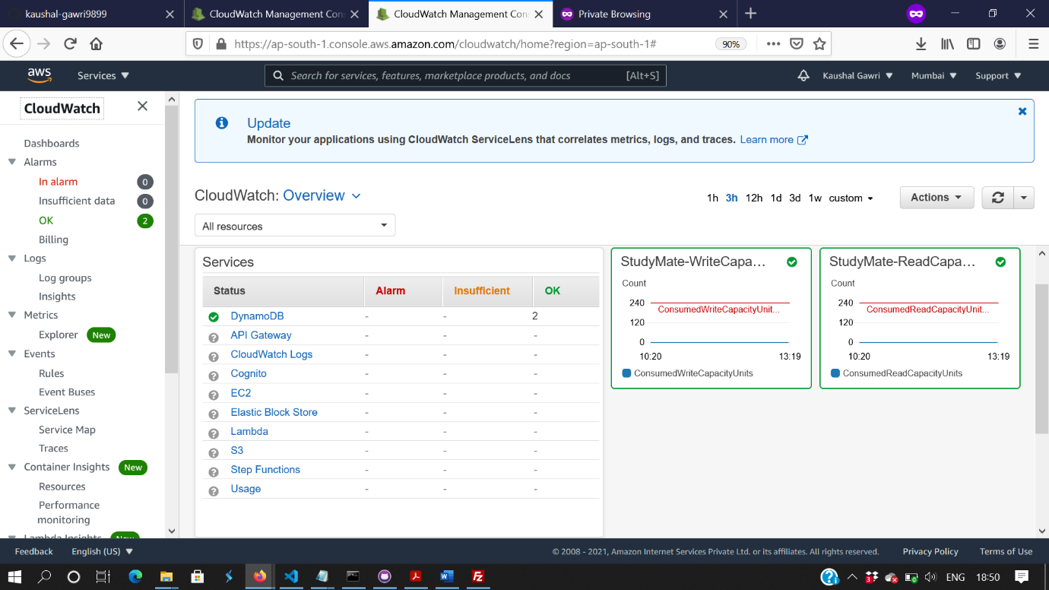

Figure 11: CloudWatch Console to see metrics and logs of your lambda functions

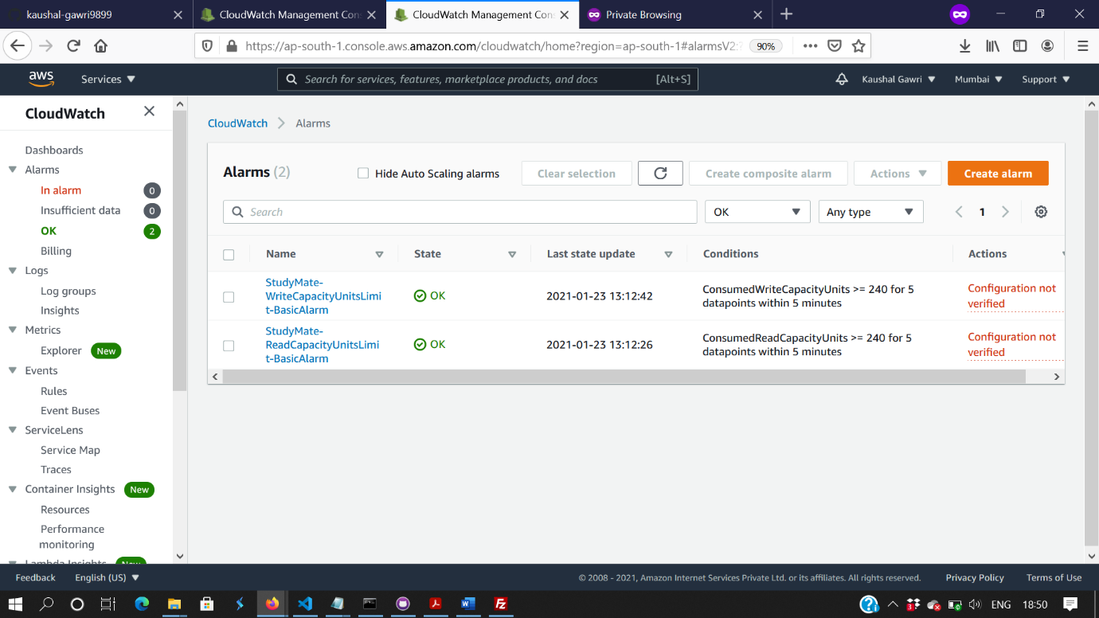

Figure 12 : Alarms provided for your dynamo DB table.

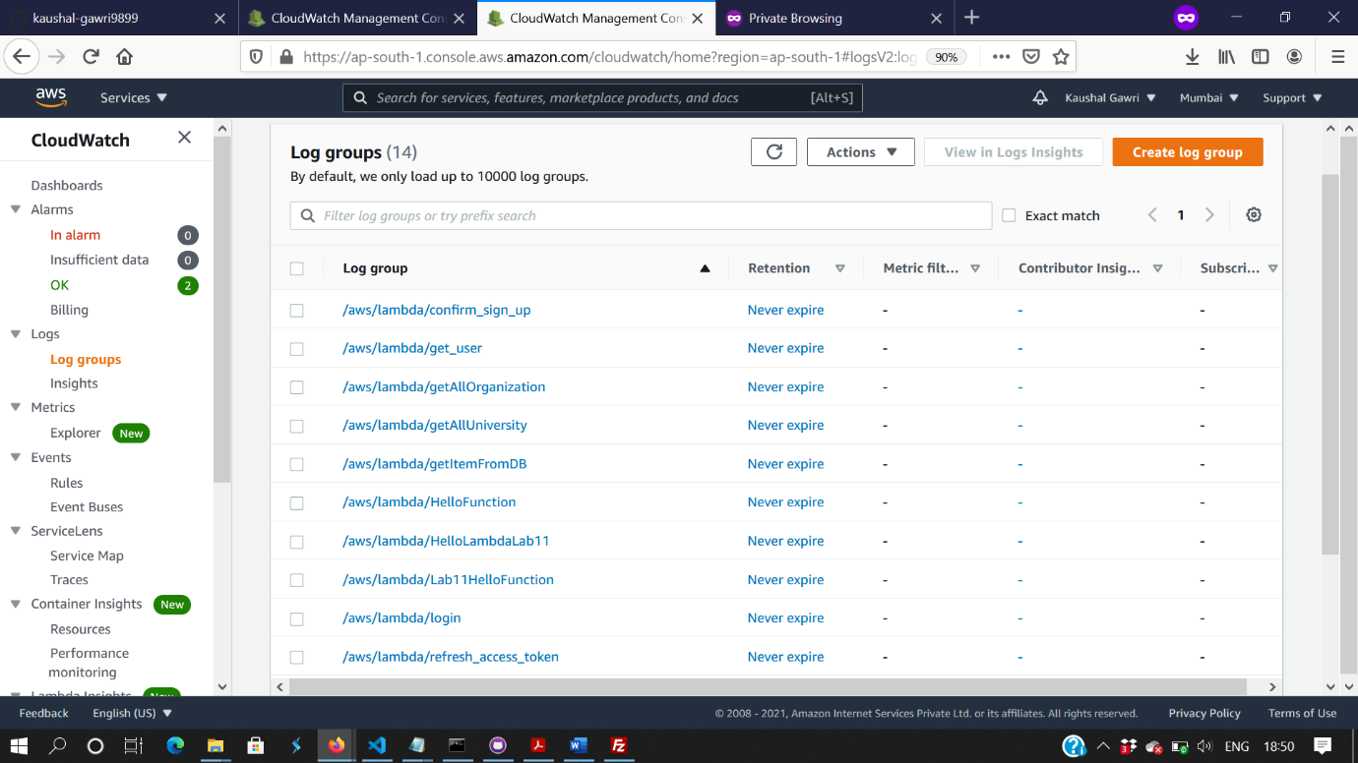

Figure 13: Log groups for all the lambda functions

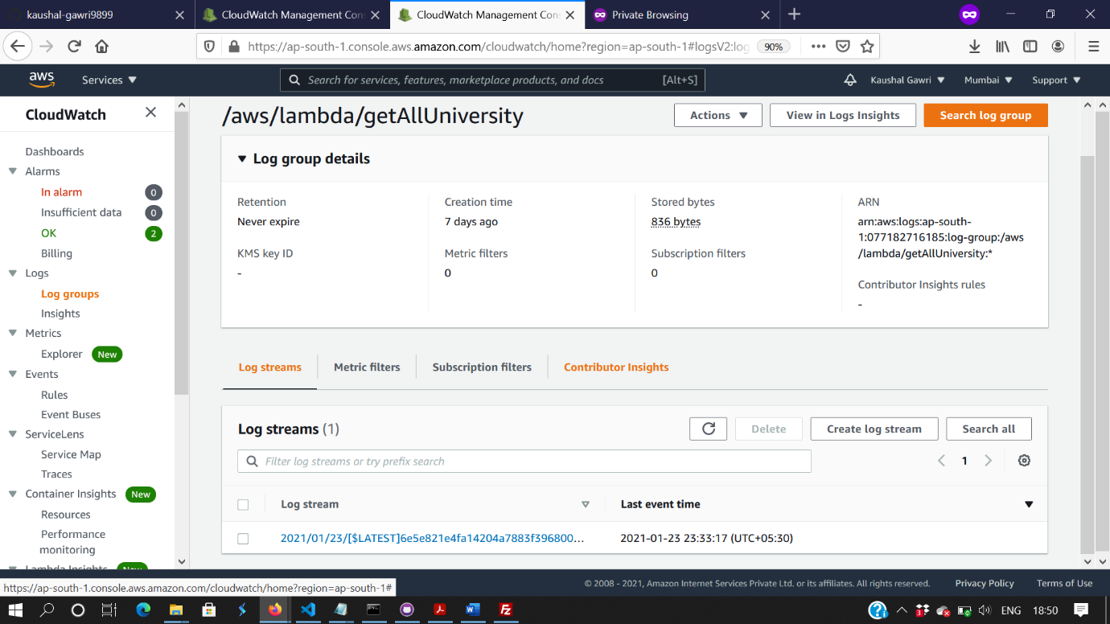

Figure 14: The logs are displayed from latest to the first time function was invoked

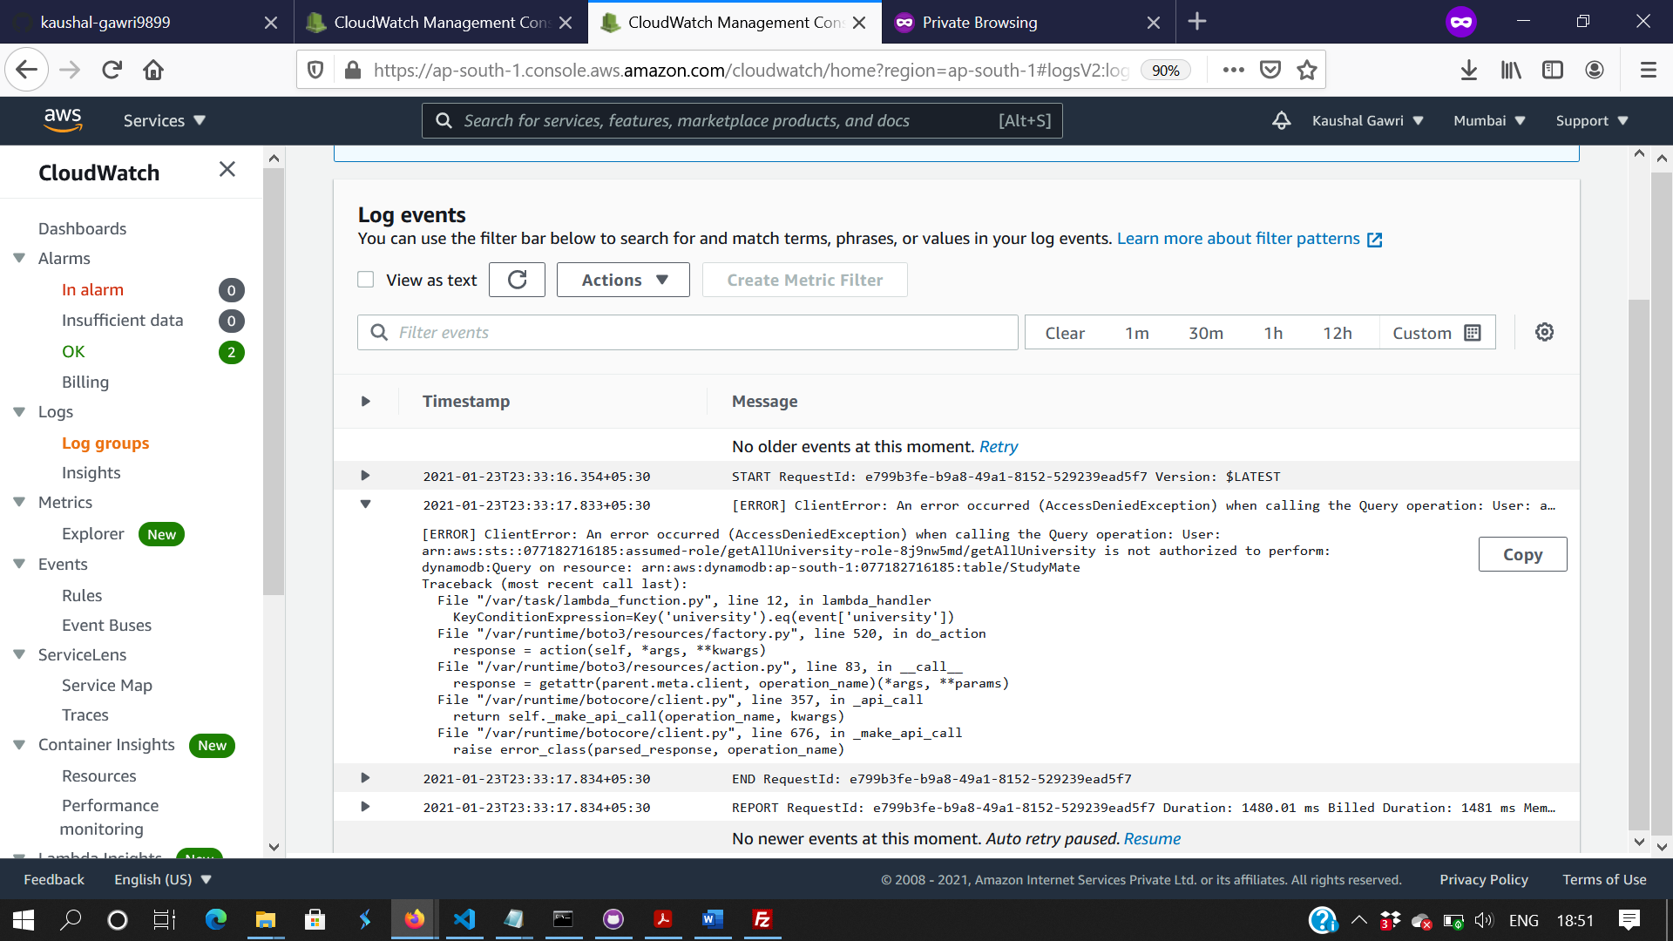

Figure 15: Information of your lambda function output on console. Helps in Debugging

## AMAZON API GATEWAY :

It is a fully managed service making it easy for us to create, publish and maintain our APIs. As API act as the door to access data and other functionality from our backend, we would be using Amazon API Gateway to create a “RESTful API” that will further enable real time updates. As, it provides serverless workloads, we don’t need to worry about the user traffic or how many times our lambda functions are invoked which makes the whole experience a lot faster and efficient. API Gateway can process tons of concurrent API calls, that a custom API will never be able to handle and thus we don’t need to worry about lags and other related issues on our application. Also, using API Gateway helps in building our cognito based authentication and further helps in integrating it with our DynamoDB database. As data is supposed to be read and written real time, this is the best fit service that can help us in building a REST API. Also, certain security roles are added using AWS IAM, that lets only selected users like the admins to access the API calls. Thus, using API Gateway is not only efficient but also secure for our implementation.

The following steps are involved to build are REST API and integrate it with our Cognito Authentication, AWS Lambda and Dynamo DB.

* Search for API Gateway in AWS Console and you would be provided with the welcome page.
* Choose the relevant API you want to build, in our case we would be using a REST API. Select REST API and give it a name.
* Now, you would be redirected to your API gateway console. From the tab menu provided on the left side of the screen click on Resources
* Create a new resource named “user”. Select the resource you just created.
* Now, click on “Actions” dropdown and create another resource. Name It as “login”
* Now, select your newly created “login” resource and click on “Actions” dropdown.
* Select “Create Method” from actions dropdown and add the microservice, here we would be using “POST” method for login. So, choose POST.
* You’ll see a new screen with your method configuration. In the “lambda function” field choose your lambda function responsible for this functionality. Here, I would be using my “login lambda function” for login functionality.
* Make sure your Lambda function and your API Gateway REST API are build in similar regions, else your functions won’t be displayed.
* Now, repeat the steps to generate API endpoints for all of your lambda functions.
* Once done, Click on “Actions” again and select “Deploy API”.
* You’re now supposed to create a new deployment stage and add some description. Once done, click on Deploy.
* You can now choose the “Stage” link form left side tab and see that your endpoints are deployed with relevant methods. You can invoke any of these methods to test your backend and then use the CloudWatch logs for debugging.
* Choose any of the resource and you’ll find a new screen for your method. There should be an invoke url provided which can be used to invoke your GET/POST/UPDATE requests using json.

That’s all, you have your REST API up and ready to be integrated with your frontend or local backend.

Next, we are required to setup our dynamo DB database and integrate that with our Cognito Authentication to fill data which can be then integrated through lambda functions with Cognito and using Microservices we would be able to make Table Operations as discussed above.

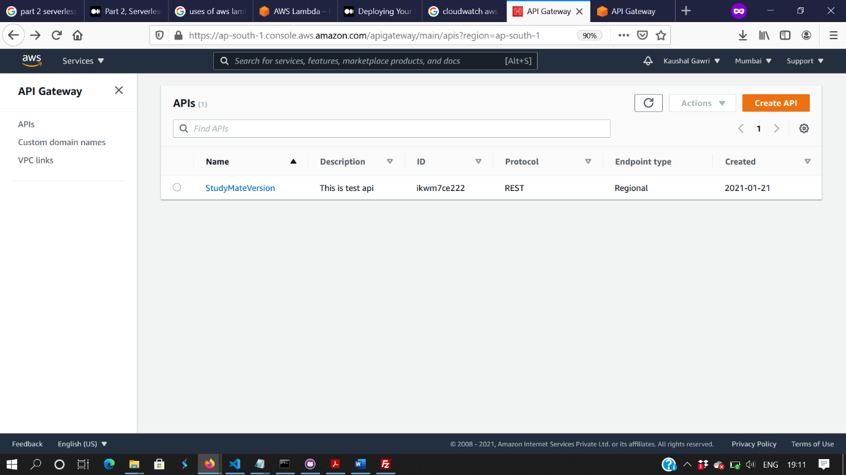

Figure 16: API Gateway Console to create a new API

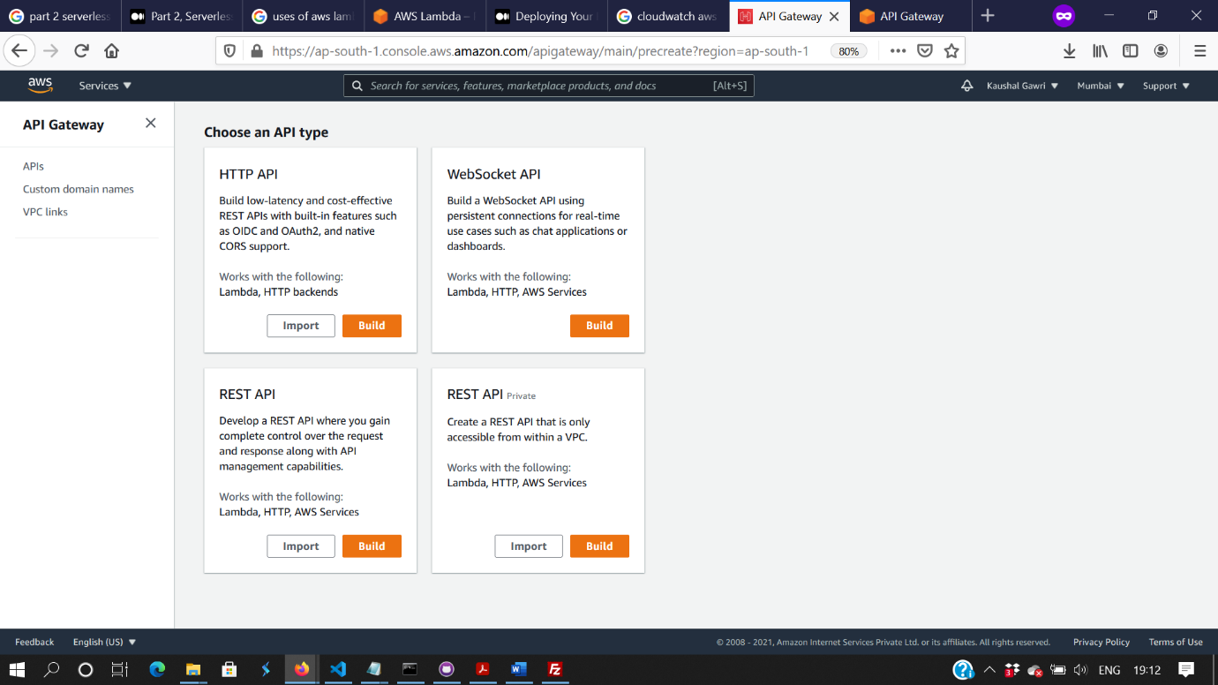

Figure 17: Choose a REST API from the provided list

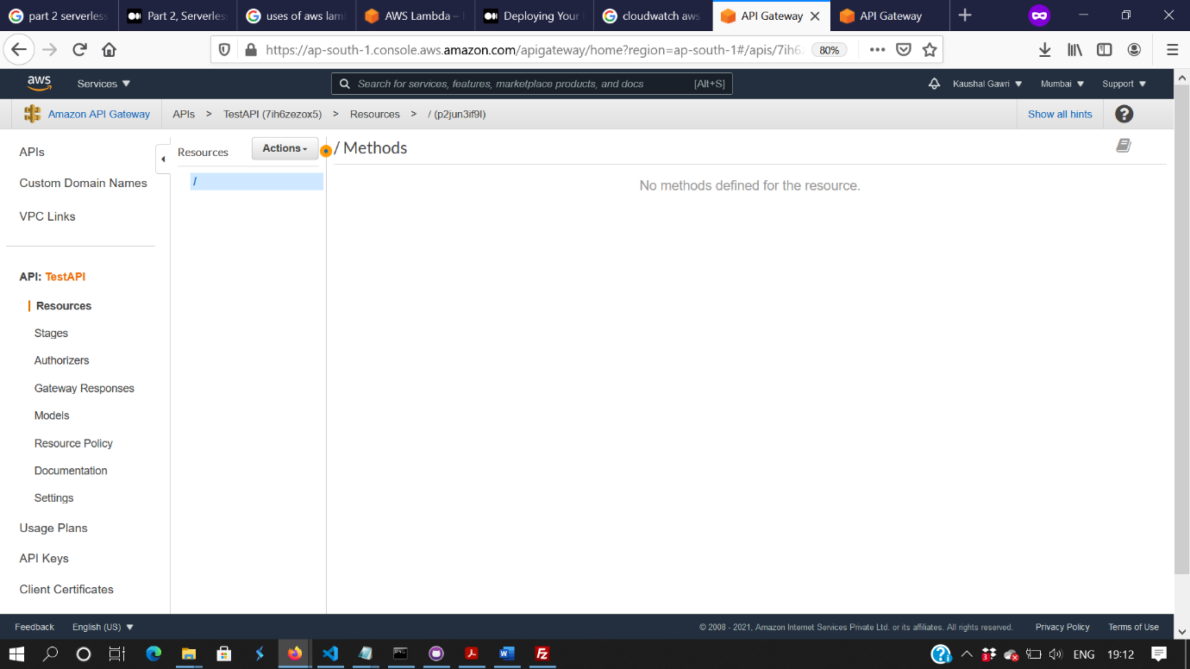

Figure 18: Add a new resource to newly created REST API

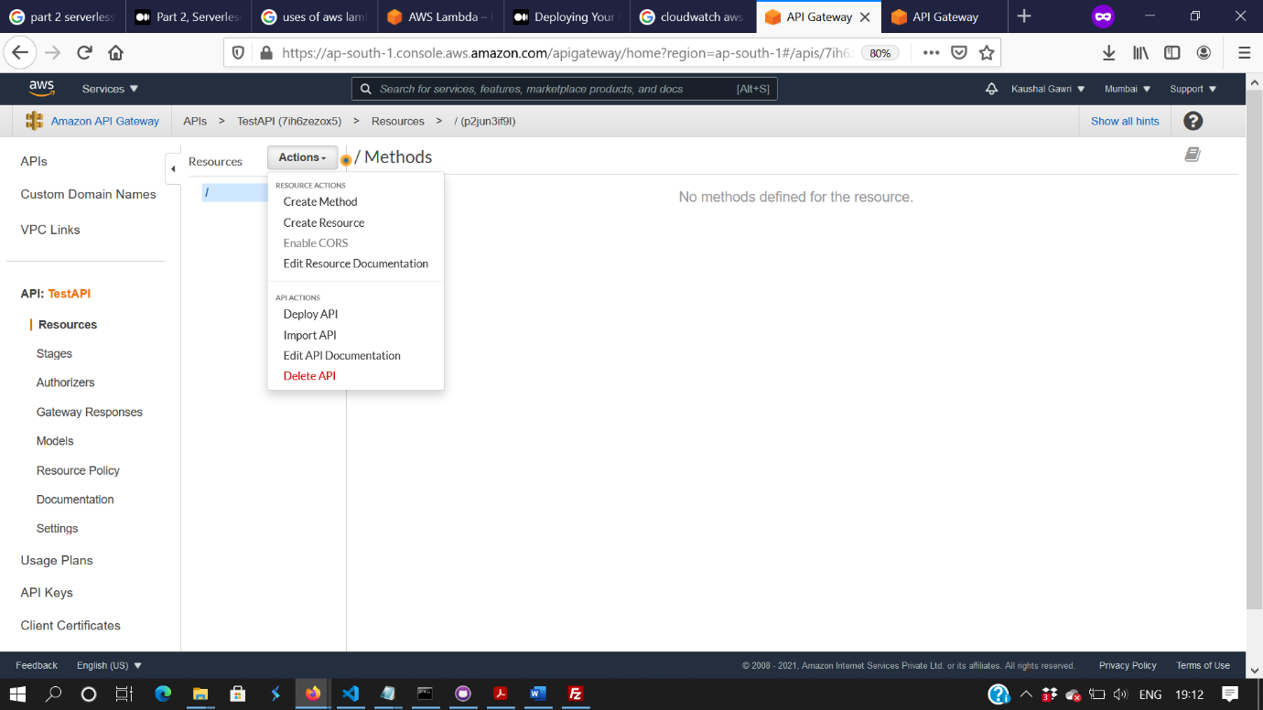

Figure 19: Add a new resource to newly created REST API

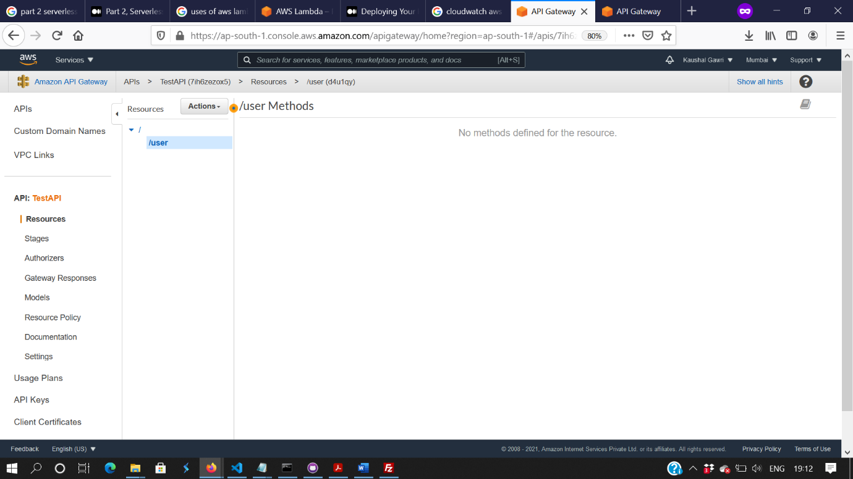

Figure 20: Add more resources like above for all your methods

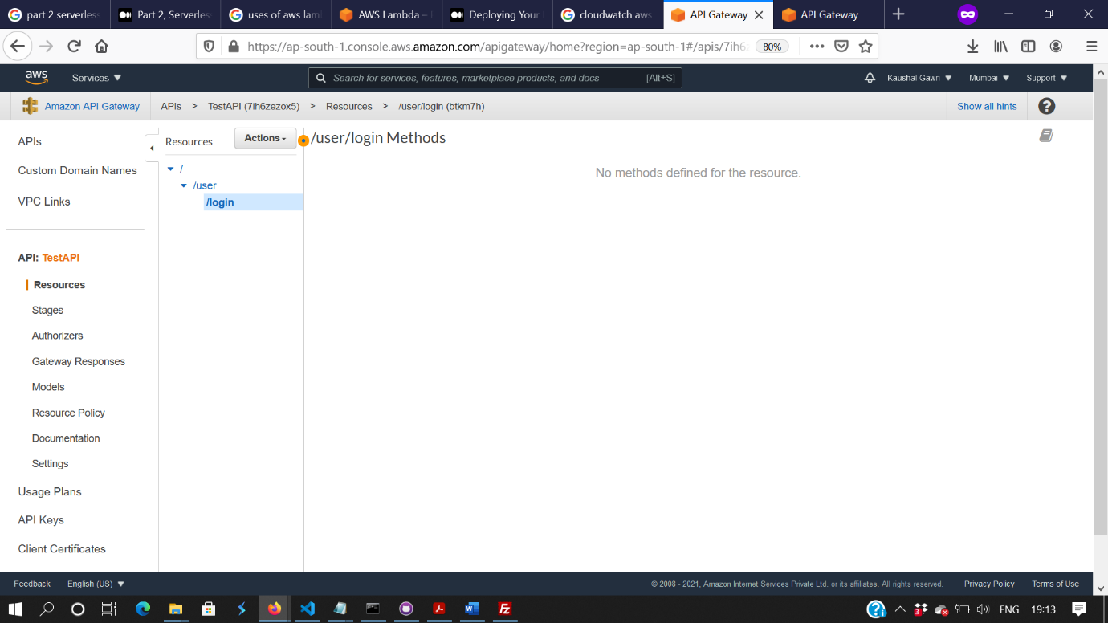

Figure 21 : Add more resources like above for all your methods

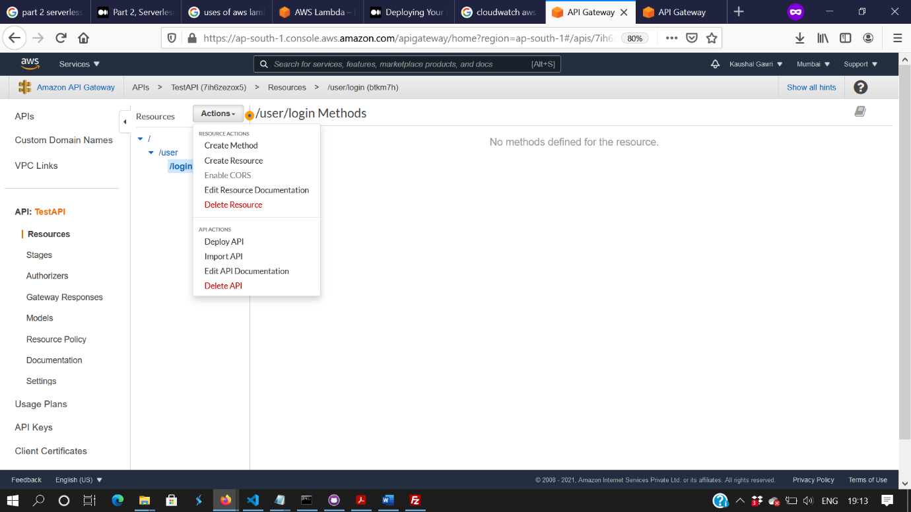

Figure 22: Create a new method for your resource

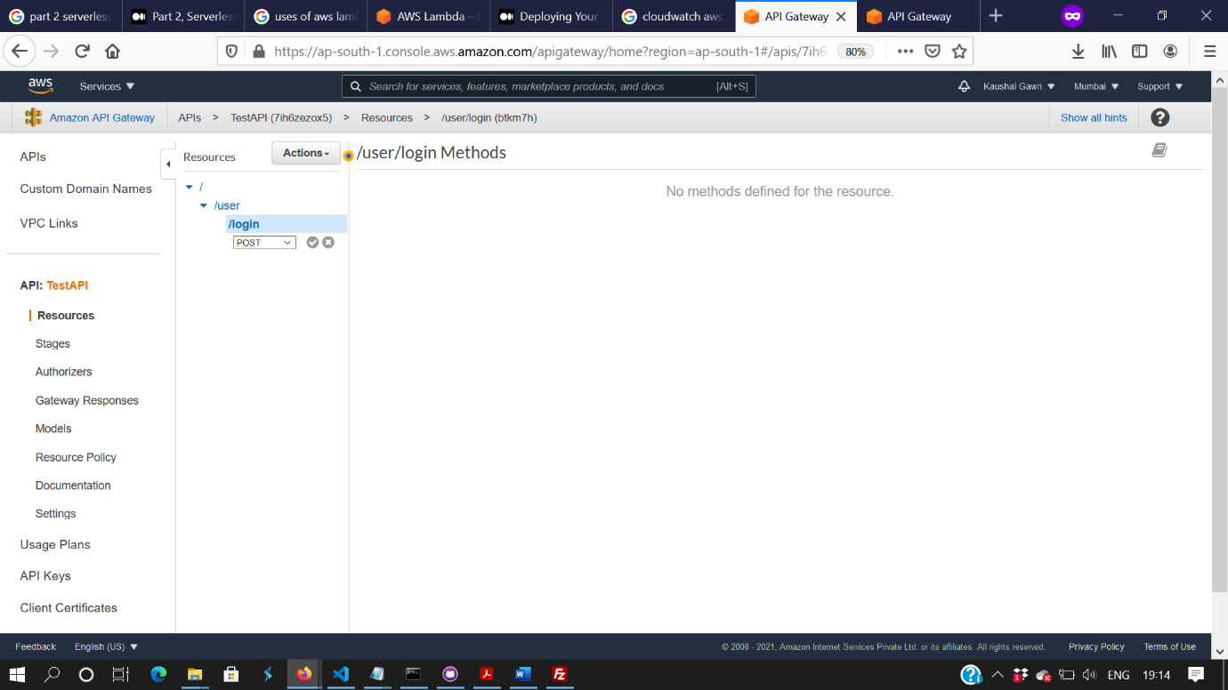

Figure 23: Add a microservice for you method

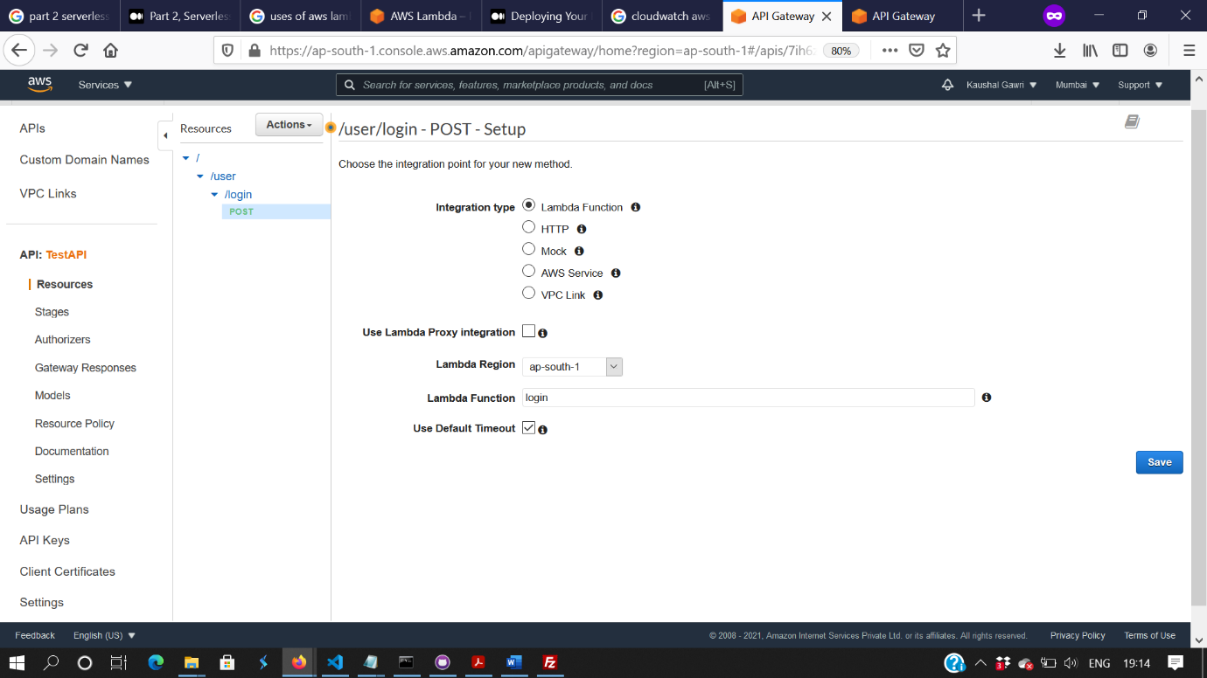

Figure 24: Configure you API endpoint with your Lambda function

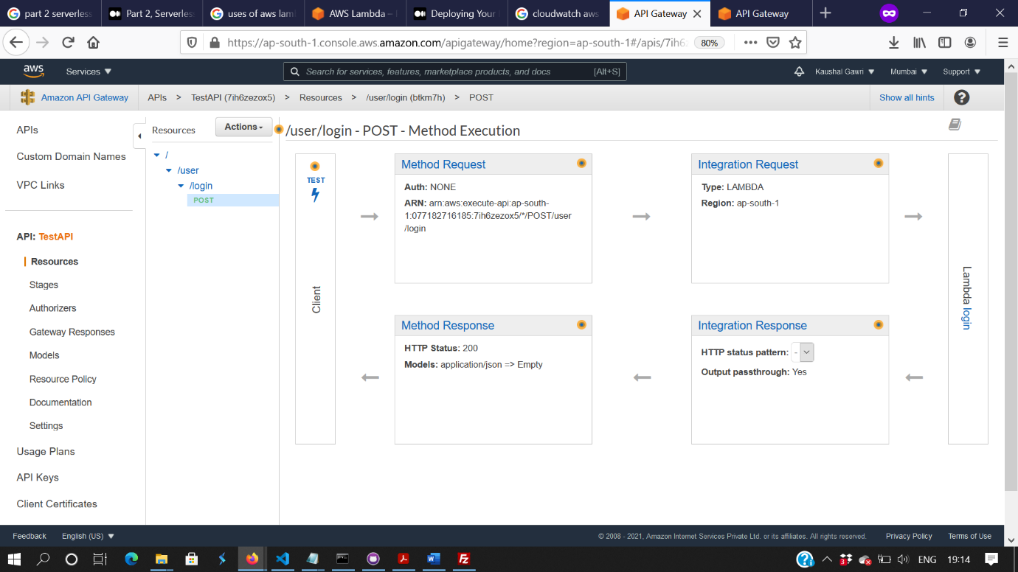

Figure 25: Displaying successful lambda function creation

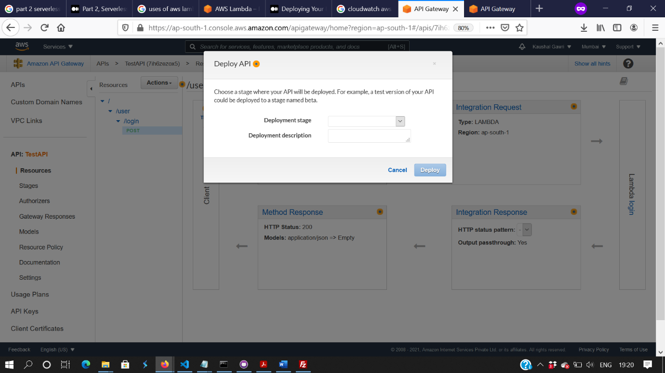

Figure 26: Deploy your API to a newly created deployment stage

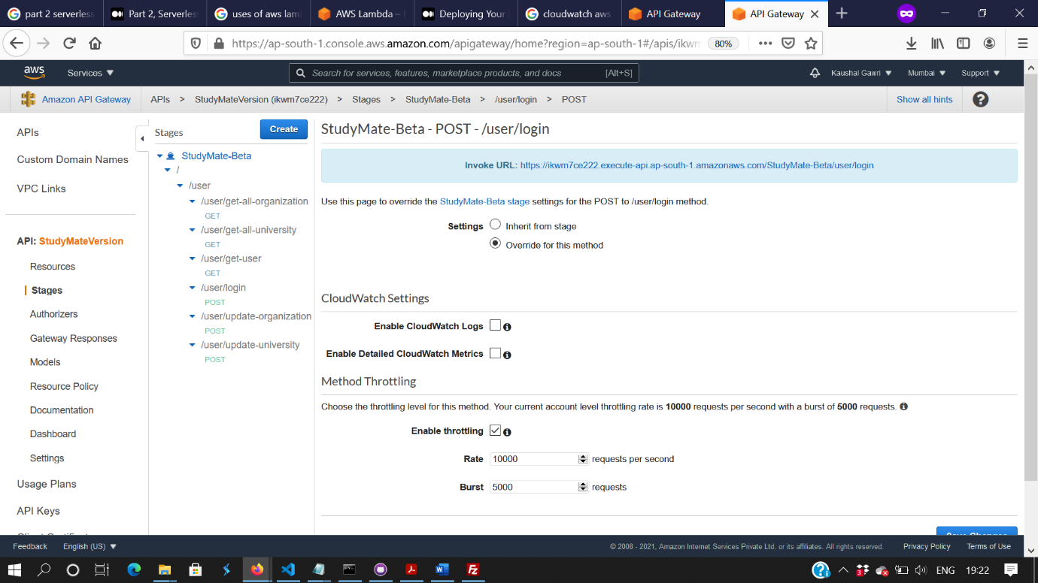

Figure 27: After deploying, the stage will look like this. Use the invoke url to test your endpoints

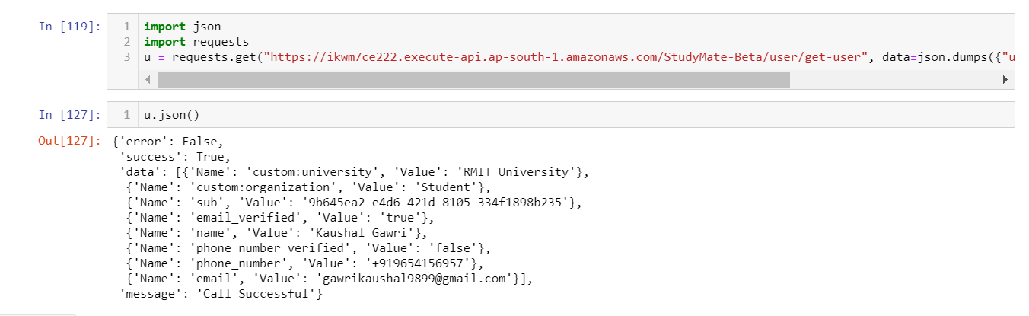

Figure 27 : Successful Call of one of our lambda function

## AMAZON DYNAMO DB

Amazon Db, being a key-value database delivering a performance of single digit millisecond could be anyone’s first choice while working with NoSQL. Also, it is multi region, so it can be accessed from anywhere in the world. As it doesn’t require any servers to manage, and automatically scales table up and down , this was something that we were looking to work with for a long time. DynamoDb can be used with a serverless backend using certain microservices, be it GET/POST or DELETE requests, and the implementation of the idea does need real time data updates to access information or make changes to user profile, dynamo db was again our first choice.

The major step in developing a fully functioning application was to integrate our database well with our Cognito User Pool. Thus, following steps were involved to achieve good flow of data from the database:

* Search for Dynamo DB In the AWS Console
* Click on “Create Table” button.
* You’ll be redirected to another page, give your table a name and select a primary key, in our case “email” is chosen as the primary key to provide uniqueness and so that multiple accounts cannot be created through a single email.
* Mark the “Use default settings” check box and click on “Create”
* That’s done, you’ve your Dynamo DB database created and it was as simple as that.
* Now, to feed the data to our dynamo DB, we would be again going back to user Cognito and AWS Lambda.
* Go back to AWS Console and Search for AWS Lambda.
* Follow the earlier quoted steps and Create a new lambda function, based on Node.JS this time and make sure you’re creating all your functions in the similar region.
* Now, use the code provided below for lambda function named as “createDataBase”
* This is the most crucial step, now search for IAM in the AWS console and go to Roles.
* Click on “Create Role”
* Select “AWS Service” and “Lambda” as a Select type of trusted entity and Choose a use case.
* Click on “Next:Permissions”
* Now, make sure you add all the roles mentioned below.
* AmazonDynamoDBFullAccess
* AmazonCognitoDeveloperAuthenticatedIdentities
* AmazonCognitoPowerUser
* Follow the prompts and finish creating the role.
* Now go back to “AWS Lambda” console and search for your lambda function you created earlier
* Select “Permissions” on your function page and on Execution Role select “Edit”
* Search for the role you just created in “Existing Role” field and select it. Click on Save.
* Once done, go to your Cognito User Pool and select your user pool you created earlier
* On the tab menu on left side, click on “Triggers”. You’ll find a bunch of events where you can add user developed lambda functions to customize workflows.
* Now, as we are required to add all the data that user inputs during sign up and add that to our DynamoDb database, we will add the recently created lambda function in the above steps as a Trigger.
* Go to “Post Confirmation” Event and add your lambda function for adding data to Dynamo Db and click on “Save Changes”.

That’s all, if you followed the above mentioned steps you should have your cognito user pool integrated with the DynamoDB database using the lambda function you just created if you added the correct region. Now, you can test your database by using the Cognito’s built in UI to register a user and his/her details should be saved in the Dynamo Db table.

Next up, we just need to use are already deployed lambda functions for the relevant features and using correct microservices like GET/POST invoke the lambda functions using the invoke_url provided and the necessary updates on our database would be made.

The last step is to create a flask based custom backend which will render our front end pages and invokes few GET/POST HTTP requests using the lambda functions invoke url to be used for specific features.

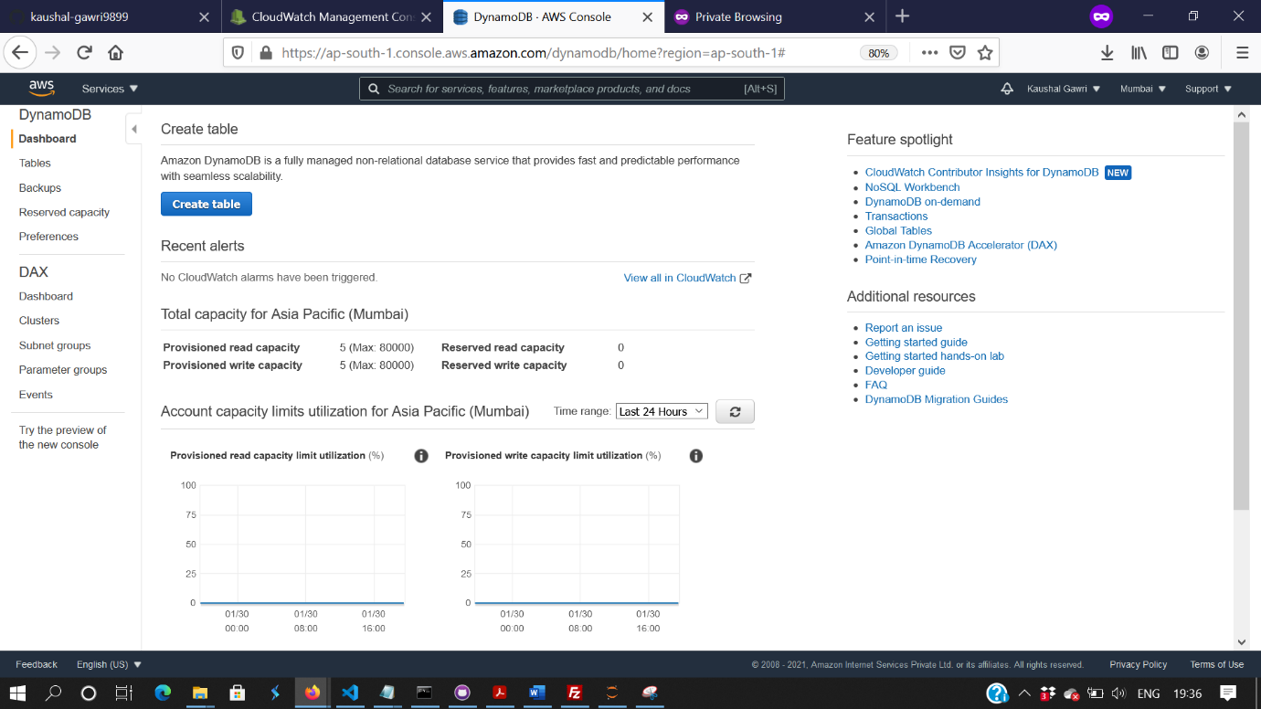

Figure 28: Create a new Dynamo Db table using DynamoDB console

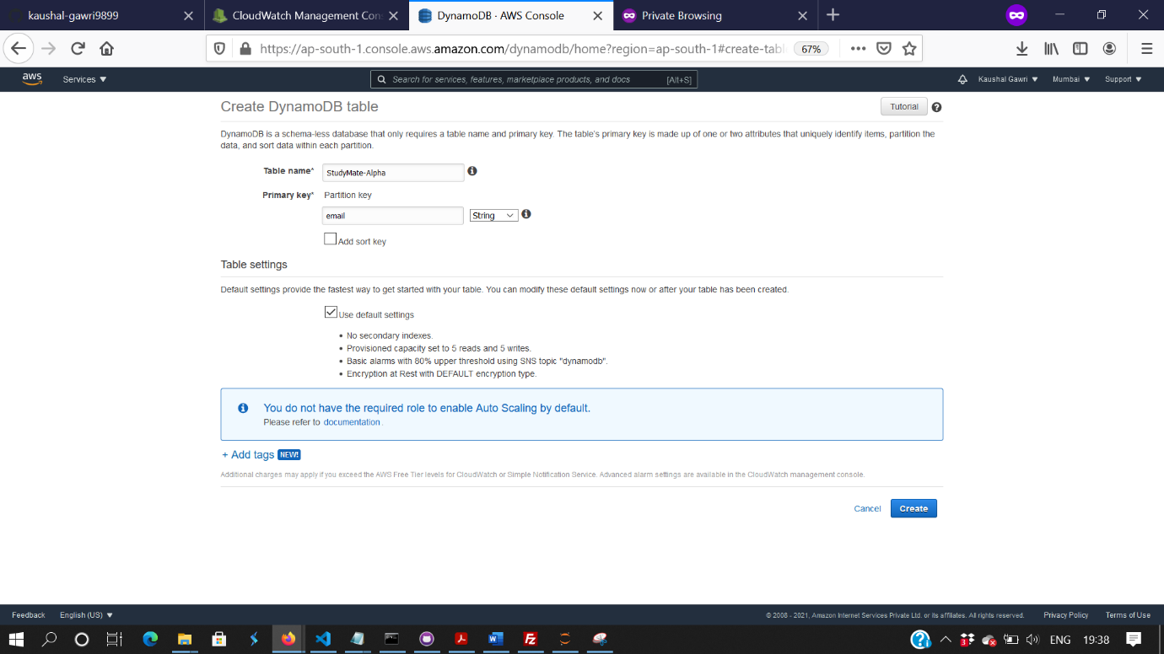

Figure 29: Add the primary key of your table and select Create

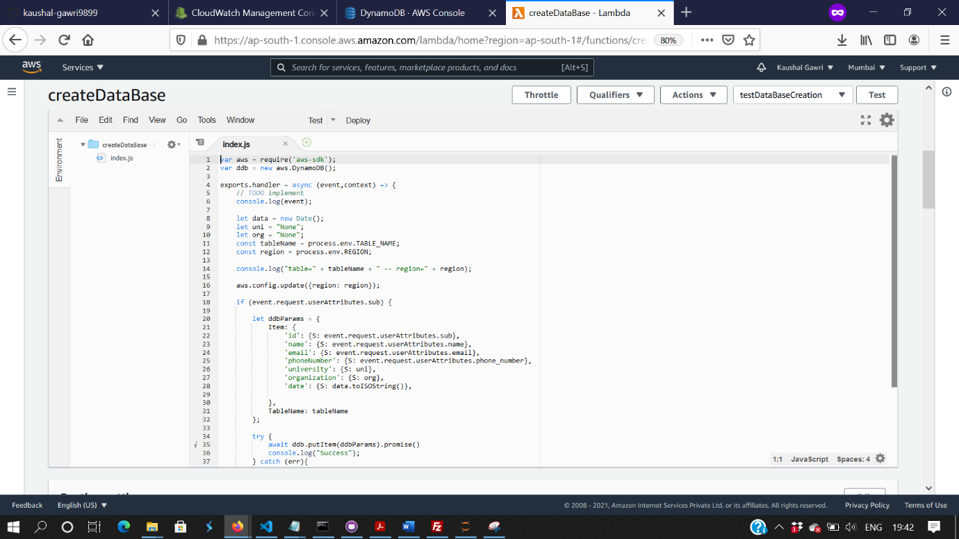

Figure 30: Create a new Lambda function for adding user data to your table

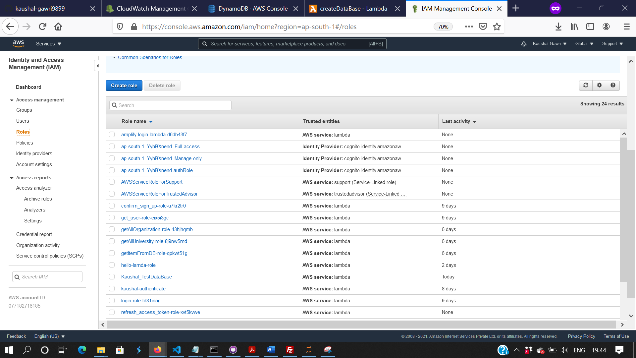

Figure 31: Create a new role for your lambda function using IAM console

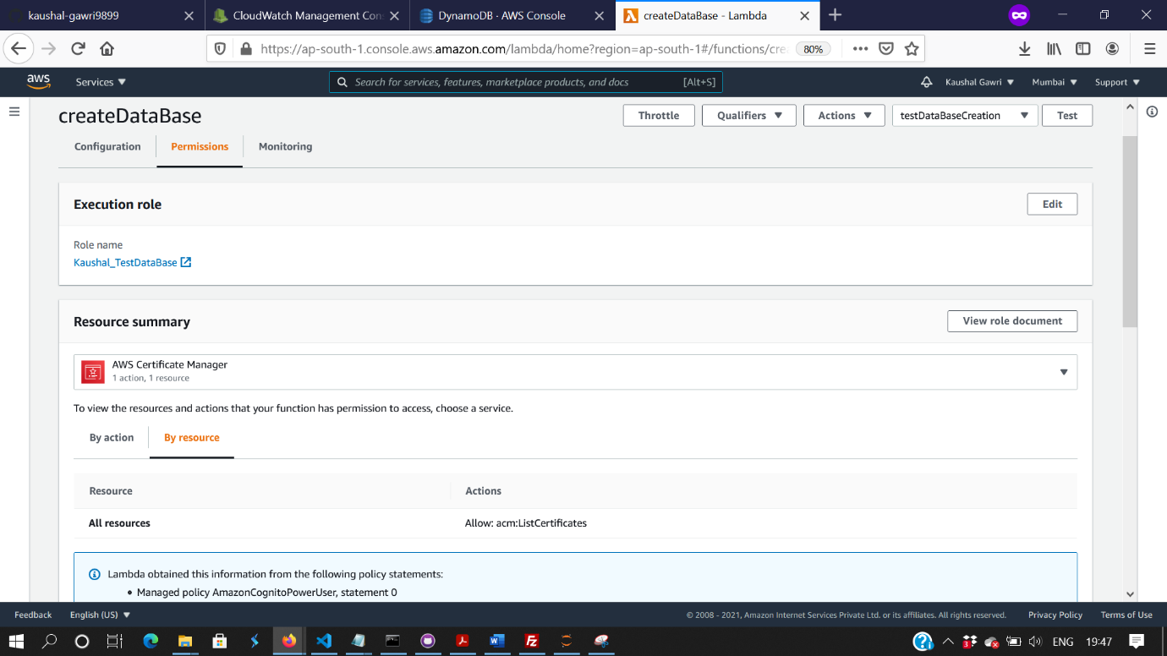

Figure 32: Add the new role in the permissions of your lambda function

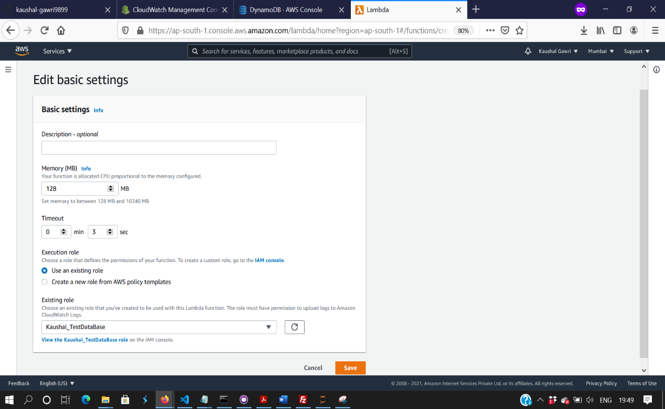

Figure 33: Select Role for your lambda function and click on Save

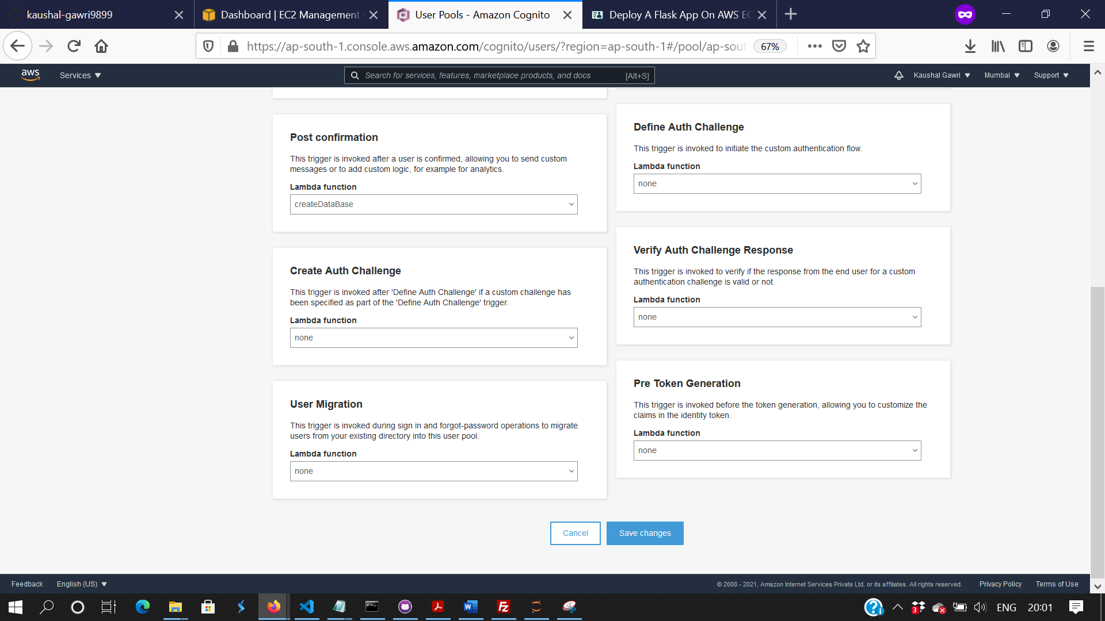

Figure 34: Add your lambda function to the “Post Confirmation” Trigger of Cognito User pool

## EC2 INSTANCE :

The major part of our implementation is to use virtual servers provided by EC2 Instance and deploy our front end along with the flask based backend that’s responsible for invoking our lambda function.

The following steps are involved to successfully launch an ec2 instance and add our code base to it.

* Go to AWS console and search for EC2 instances
* Click on Launch Instance and select **Ubuntu Server 16.04 LTS (HVM), SSD Volume Type — ami-43a15f3e. The exact name may be changed.**
* **Now make sure to add the relevant security groups. It should be :**
* **HTTP**
* **HTTPS**
* **SSH**
* **Custom TCP Rule**
* Make sure to choose Source as “Anywhere”
* Now, you’ll be asked to add a private key, if you already don’t have one you can create one from the option provide and then select on “Launch”.
* That’s all, you’re Ec2 instance is launched
* The next step is to setup your instance using the terminal
* For this, change your directory to where you’ve placed your security key downloaded earlier
* Now, Connect to the instance using the following command on terminal

ssh -i "yourapp.pem" [ubuntu@yourapppublicinstance.compute-1.amazonaws.com](mailto:ubuntu@yourapppublicinstance.compute-1.amazonaws.com)

* Make sure you update any of the packages and install apache webserver and mod_wsgi.

sudo apt-get update

sudo apt-get install apache2

sudo apt-get install libapache2-mod-wsgi

* Now, the next step is to install flask using the “pip” tool. If it’s not installed already follow:

sudo apt-get install python-pip

sudo pip install flask

* Redirect yourself to /var/www/html directory. And remove the already present index.html file.
* Create a new directory for your flask app, we named it StudyMate
* Now, in the directory add your flask app which have correct routing and all the methods implemented.
* Next step is to create a .wsgi file to load the app, for now, our .wsgi looks like :

#flaskapp.wsgi

import sys

sys.path.insert(0, '/var/www/html/StudyMate)

from StudyMate import app as application

* Now, this is a crucial step. We need to enable the mod_wsgi production server. So, change your directory to /etc/apache2/sites-enabled/000-default.conf and add the following content after “DocumentRoot /var/www/html line

WSGIDaemonProcess StudyMate threads=5

WSGIScriptAlias /var/www/html

<Directory StudyMate>

WSGIProcessGroup StudyMate

WSGIApplicationGroup %{GLOBAL}

Order deny,allow

Allow from all

</Directory>

* Now, make sure you have your html files present in a folder name “templates” and your css/js/images in a folder name “static”. This will help you skip debugging which took us quite some time
* Now, restart your apache server using :

sudo systemctl restart apache2

That’s all, your whole web application with flask as your backend and the relevant front end is deployed on the virtual server provided by Ec2. You can now click on the Ec2 instance DNS or Public IP and should be redirected to the relevant page based on your main.py file.

You can now make changes to your flask app and see them live on your production server but make sure to restart the apache2 server every time you push an update.

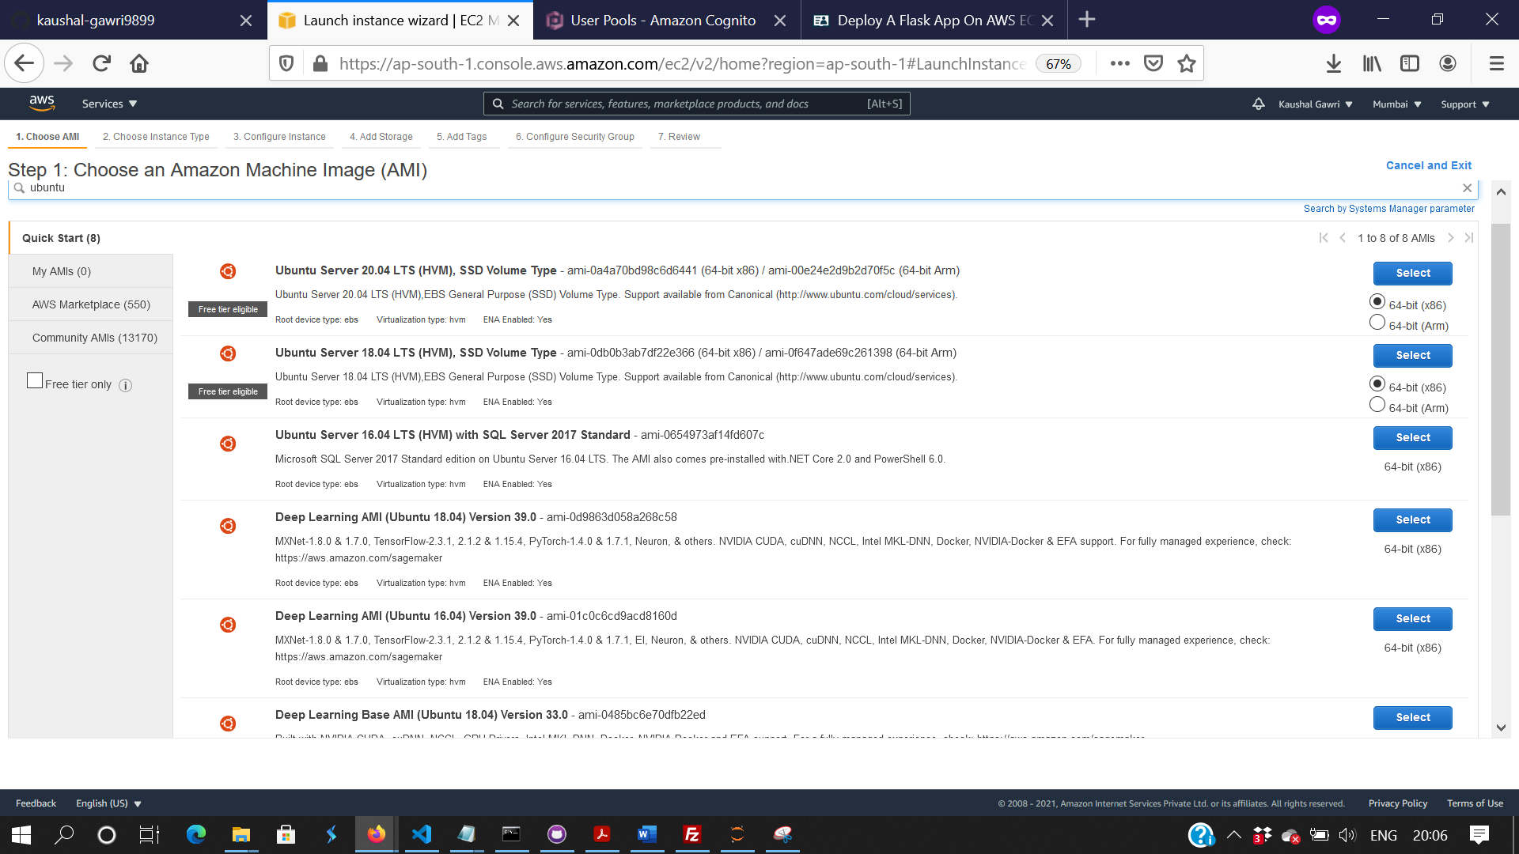

Figure 35: Create a new Ec2 Instance

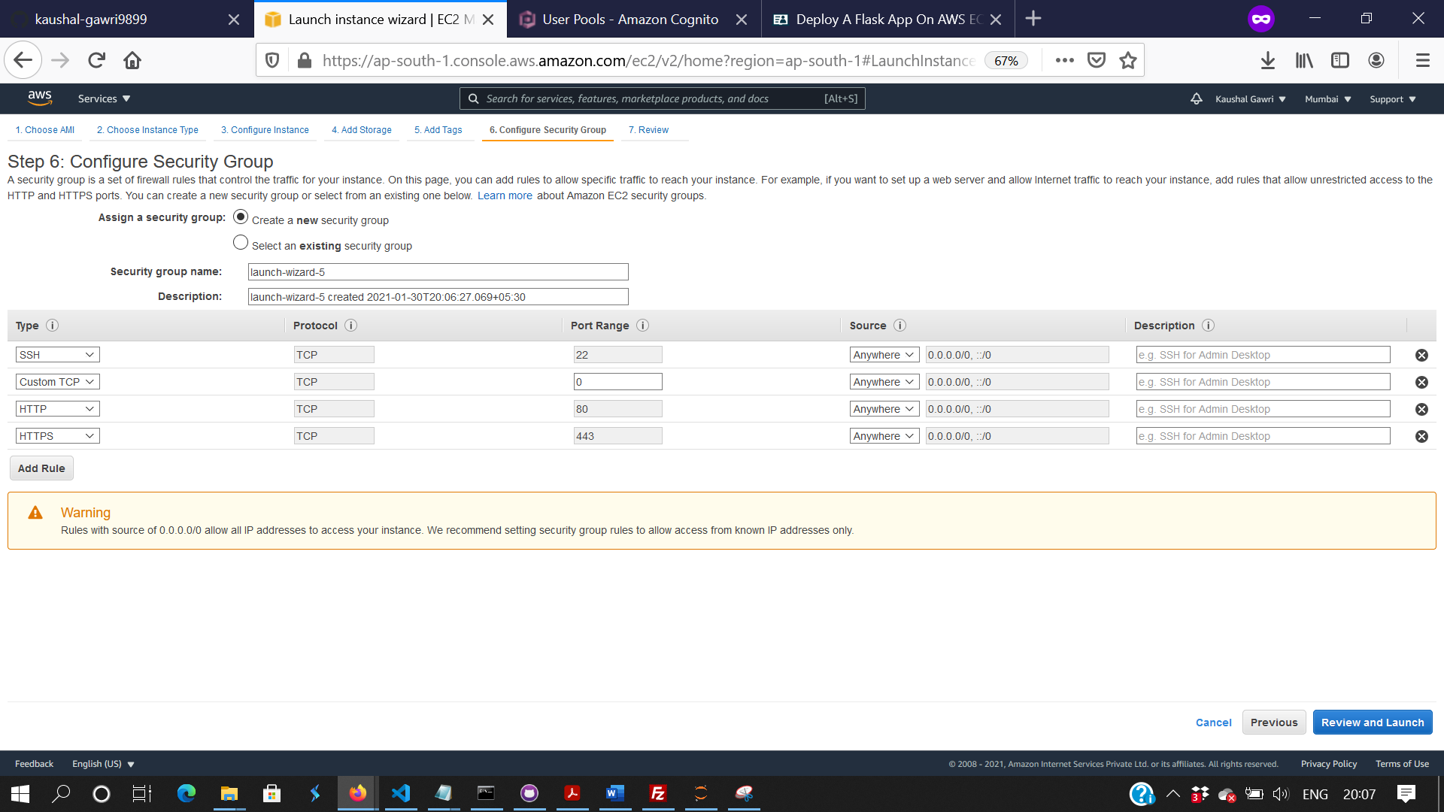

Figure 36: Add the relevant security groups to your Ec2 instance

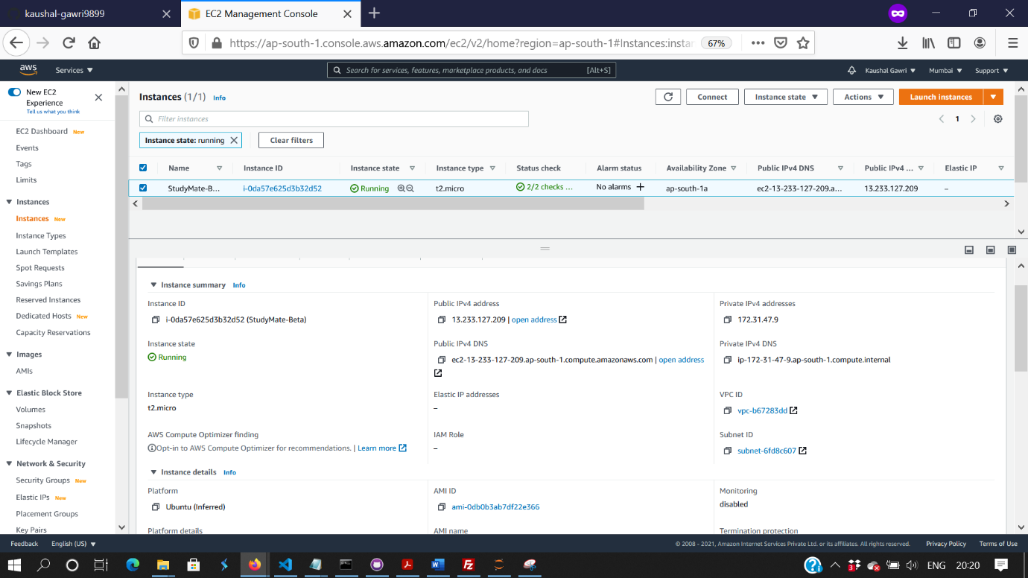

Figure 37: Ec2 Instance screen showing DNS and Ip address upon successful creation

**StudyMate Architecture**

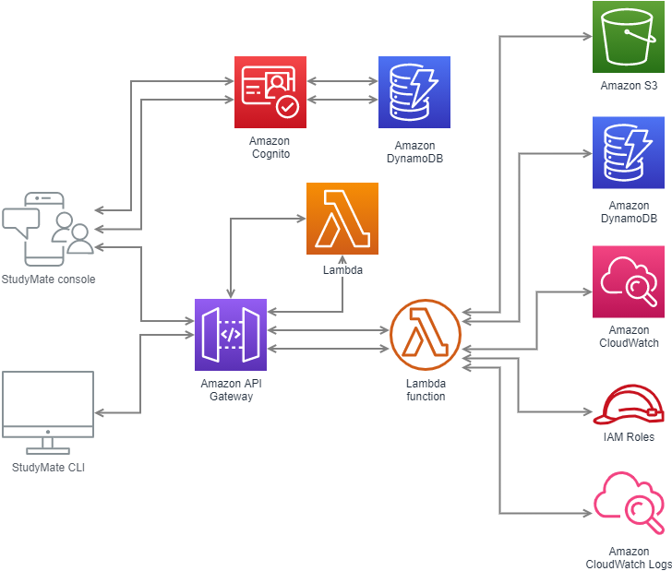

StudyMate, an app that is used to connect you with your mates. The webapp is designed on PHP and JavaScript and hosted on an EC2 instance running Ubuntu Server 18.04LTS with apache2. User sign in and registration is handled by AWS Cognito running with DynamoDB. AWS Lambda is used to run the REST API for the app by registering specific end points for GET/POST methods.

Filter Page results are reflected from the datastore created on DynamoDB store the details that user enters while signing up, work with some Microservices like GET, POST and UPDATE to “update user profile” and retrieve “Search results” from database. Every service and resources are being monitored by AWS CloudWatch to debug the production code based on log groups for different lambda functions and DynamoDB database.

StudyMate Meeting is working separately on a different server and uses Amazon Chime with DynamoDB to handle all meeting request.

# What is StudyMate Meeting?

StudyMate meeting is a cloud-based collaboration service for video/audio conferencing, screen sharing and live chatting, that helps you to stay connected with your friends or team. StudyMate is a no-registration webapp, that does not require you to sign-in or register, which makes it quick and convenient. StudyMate is a free service, that does not not require you to pay anything for the public and private chatrooms including all the premium feature like, screen sharing, video streaming, live chatting and many more.

* Features

1. Teams: A team can create or join an existing channel on the website and inside the meeting, user can chat, group video/audio call or video stream all at one place.
2. Meetings: Organising meeting are fairly easy with StudyMate, create a meeting name with your preference and share it with other people to let them join.
3. Chatrooms: Chatrooms have been on internet from ages but StudyMate offers Video Chatrooms, that not only let you chat but video chat with all the premium feature like screen sharing, video streaming or video/audio conferencing.
4. Screen Sharing: An ability to share your contents from your screen live is an important feature now, that allows you to share your screen to anyone around the globe.
5. Video Streaming: Using screen sharing to stream video files can be choppy sometimes, but a feature that lets you stream video files directly with your team mates live helps you save time and work more efficiently.

# Services used to implement StudyMate Meeting.

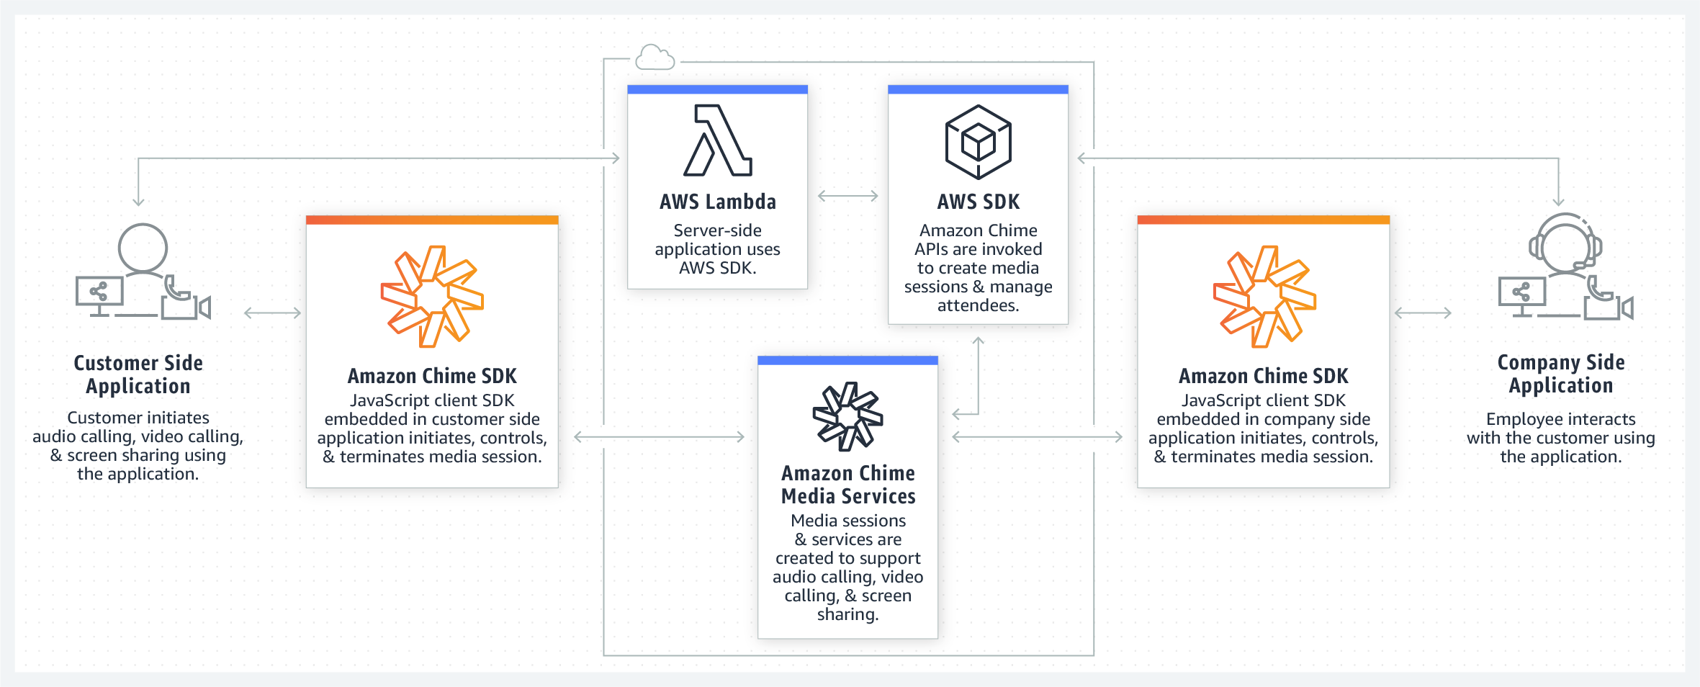

1. AWS Cloud9: StudyMate was implemented using AWS Cloud9, that is a cloud-based integrated development environment (IDE), which is used to create, run, and debug code simply using the browser itself.
2. Amazon DynamoDB: All the data was such as meeting ID; attendee ID and passwords hash are being stored on Amazon Dynamo DB as the primary database.
3. Amazon EC2: StudyMate Meeting is running on a powerful t3.medium Ubuntu machine for handling high number of request and to provide better response time.
4. Amazon API Gateway: Amazon API Gateway used to create a REST API for the production server to handle specific end points for GET/POST methods.
5. AWS Lambda: StudyMate Meeting is a server-less webapp, running solely on AWS Lambda without even a need of additional server.
6. AWS Identity and Access Management: AWS Identity and Access Management is used widely in our project to define app specific permissions for each service and users, using the service. This helps in controlling the access to the apps that doesn’t need to get root access and proving them access to the required resources.
7. AWS CloudFormation: StudyMate meeting infrastructure is designed on AWS CloudFormation. It helps in creating a model of combining AWS resources as per the requirement and managing them together.
8. AWS Chime SDK: StudyMate Meeting is using powerful AWS Chime API for the backend. This helped in integrating important service like video chat, share screen, and video streaming in the webapp.

## Server-Side Setup

1. Logon to your AWS account and search Cloud9 console.

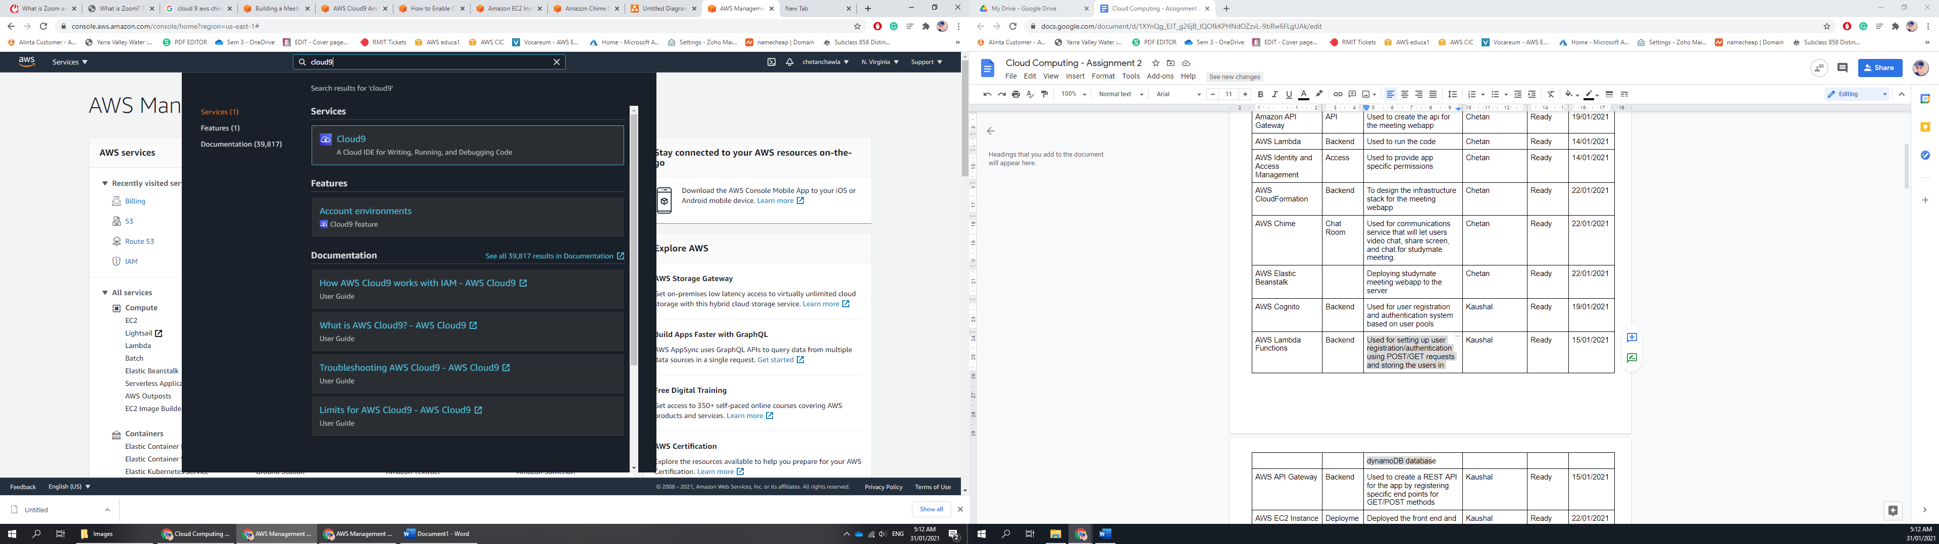

1. Click Create environment to start working on the IDE.

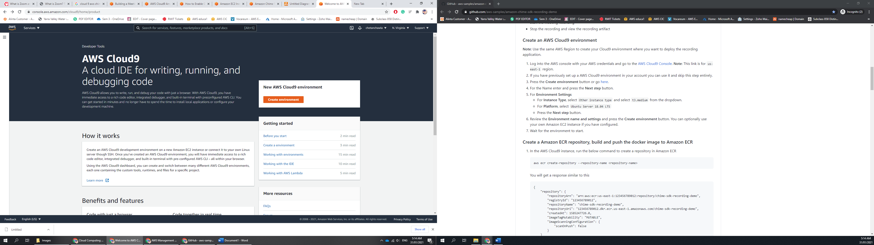

1. Enter your preferred name for the application and Click next

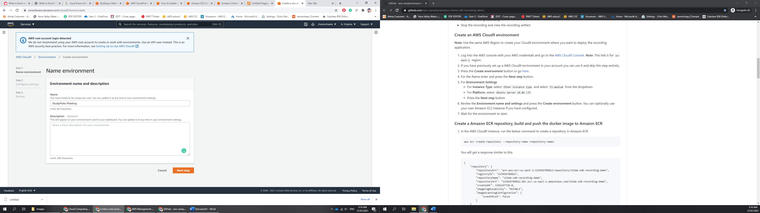

1. Select the Instance Type to be t3.medium from the dropdown and for Platform, select Ubuntu Server 18.04 LTS

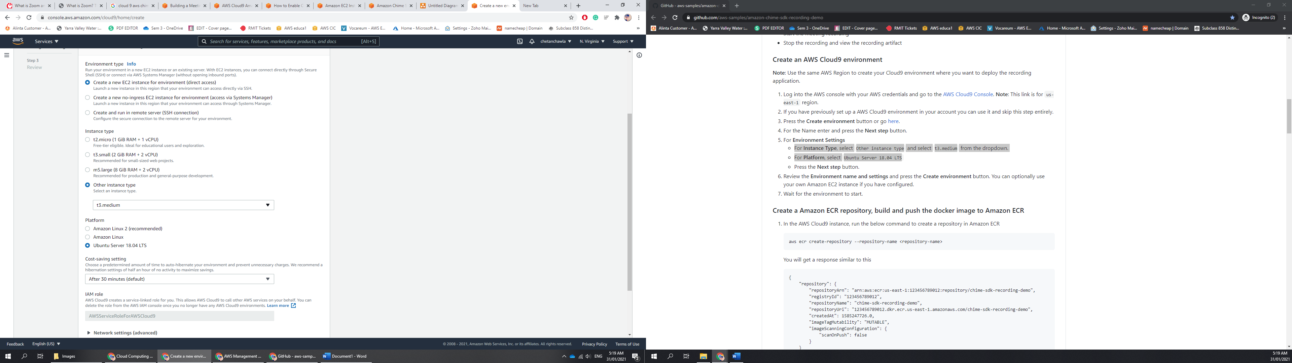

1. Review all the details and click create enviournement button. Once finish, it will give you an option to open IDE.

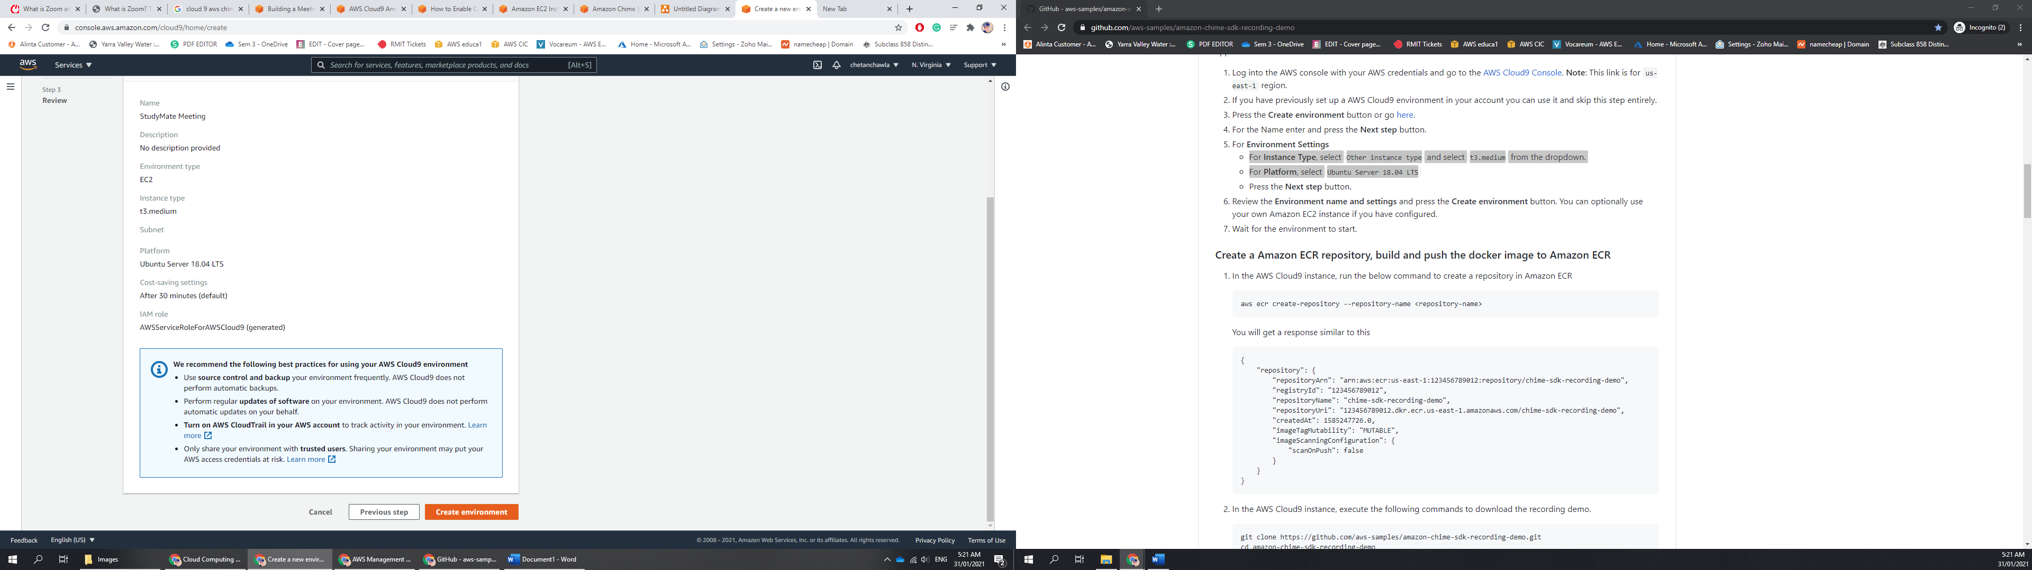

1. Click on open IDE.

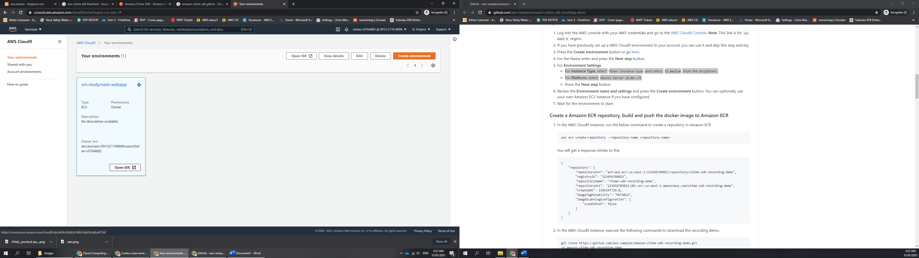

1. Clone the SDK from the AWS Sample GitHub Page.
2. Once download, change your directory to the SDK directory and Install the dependencies in the local node modules folder.
3. Create a s3 bucket for data storage and cloud formation stack to manage resources and templates.
4. Once finished, use npm ./deply with the region, bucket name and stack name to run the application.
5. Once the application will be deployed, it will show you the URL on the terminal screen.
6. Use the HTML to use the API content and integrate it on your website.

## How to use StudyMate Meeting?

1. Visit [www.studymate.gq](http://www.studymate.gq) and scroll down to what we offer.

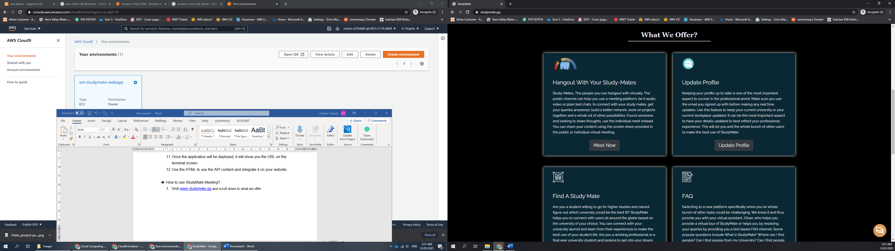

1. Click on the first icon, meet now.
2. If you are already signed in, you will be redirected to the meeting webpage, if you haven’t either sign in or create a new account.

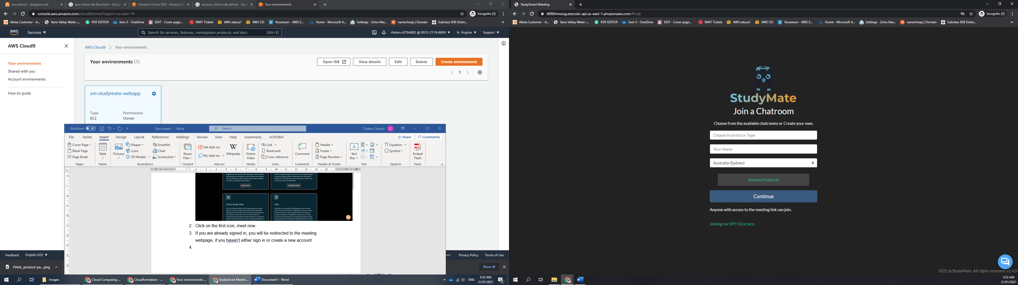

1. Once on the meet now webpage, either choose a name from the list for public chatroom or type your own.

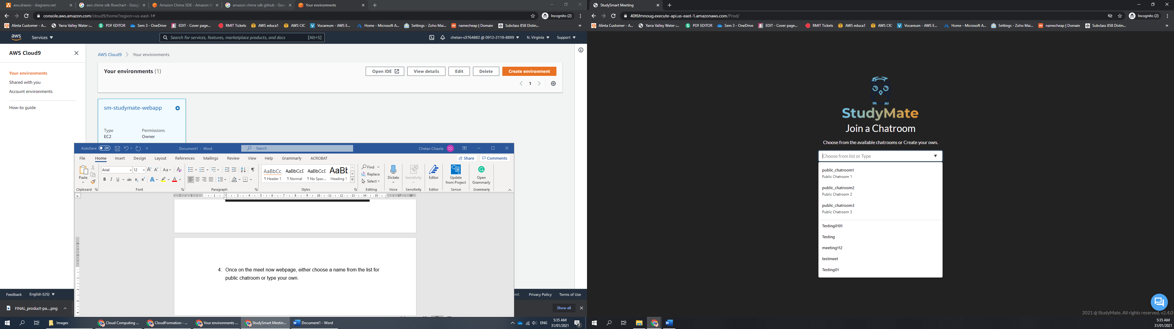

1. Fill in your name and select your location from the dropdown list. Once done. Click continue.
2. Configure your device options like your camera, microphone, speaker and the quality of the stream.

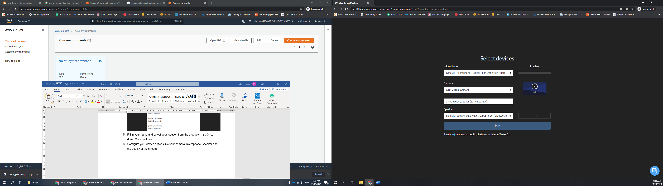

1. Confirm changes and click join, once joined, send the URL to your friend and team to let them join the meeting.
2. Once done with the meeting, click leave meeting on the very top right of the screen.

# USER MANUAL

Here is a quick user manual provided for rest of the features that StudyMate has to offer apart from StudyMate Meeting :

**SIGN UP / LOG IN**

1. Once you open the <https://studymate.gq> url, you will be redirected to our home page. You’re supposed to log in to the web application in order to access all the features.
2. To Log In, click on the Sign Up Page provided

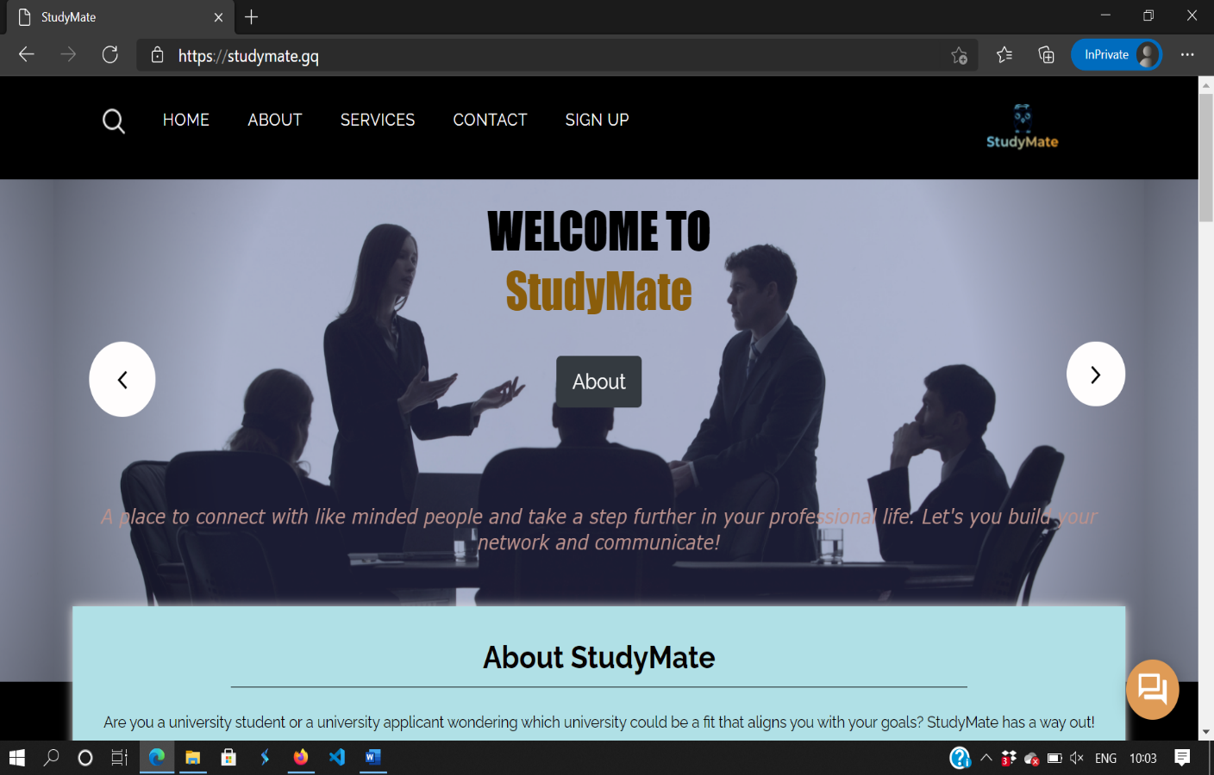

1. Next up, you’ll be redirected to another page that uses Cognito authentication to provide you access.

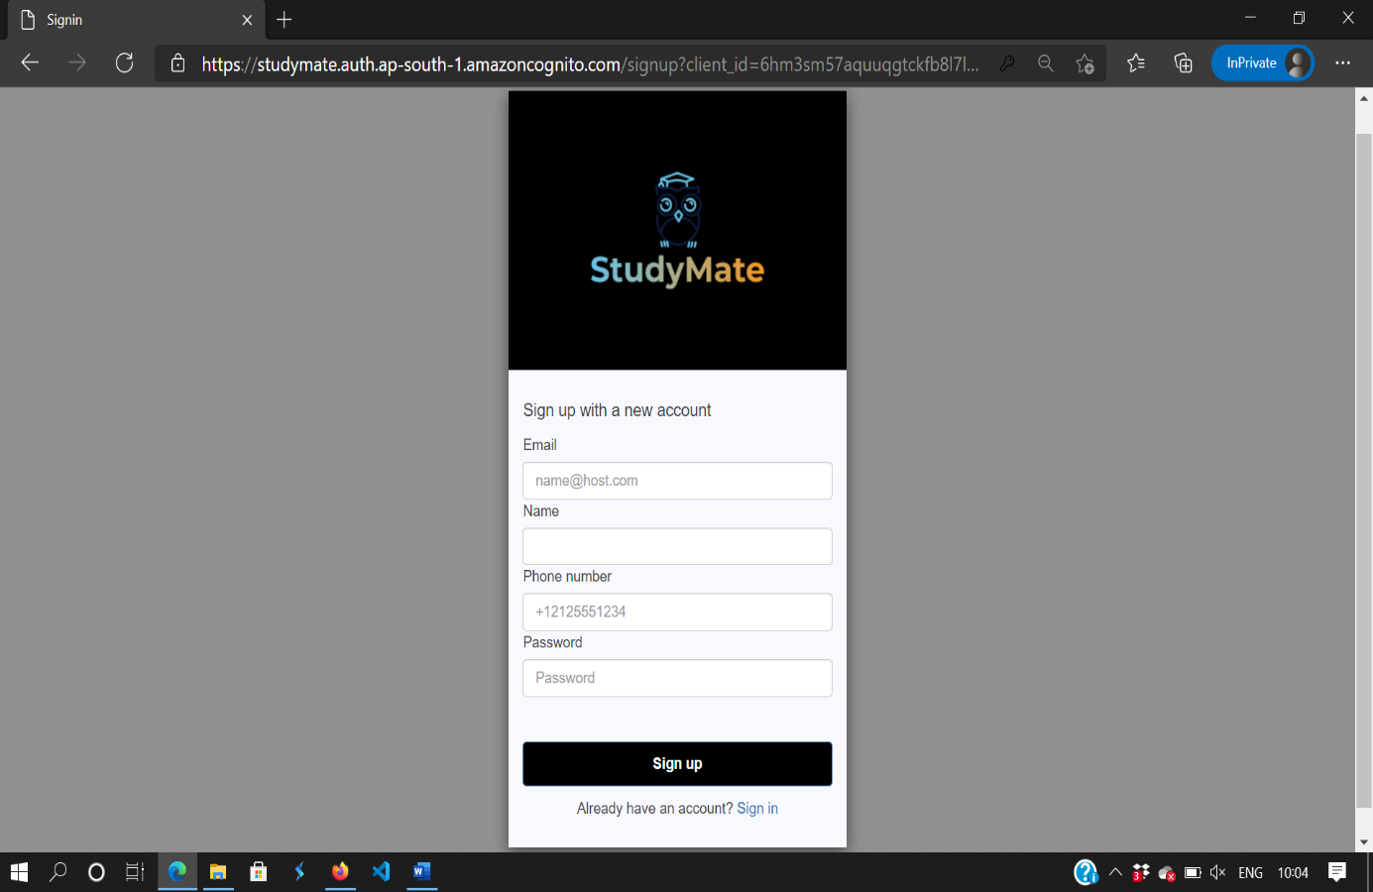

1. If you don’t have an account use the sign up page to create one, else click on “Sign in” link provided.

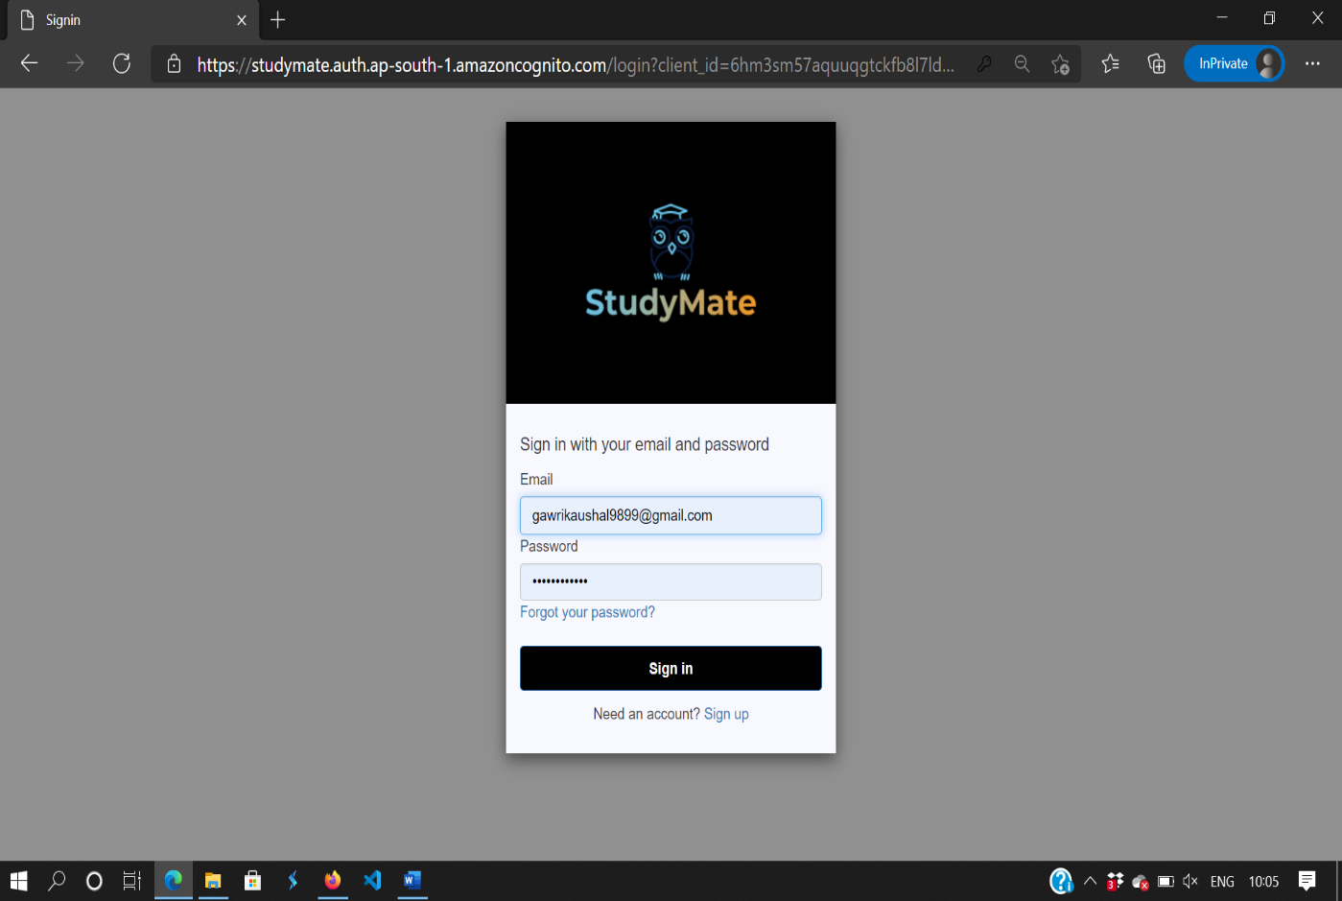

1. Now, fill in your details and Click on the Sign In button, You’ll be redirected to our homepage again.

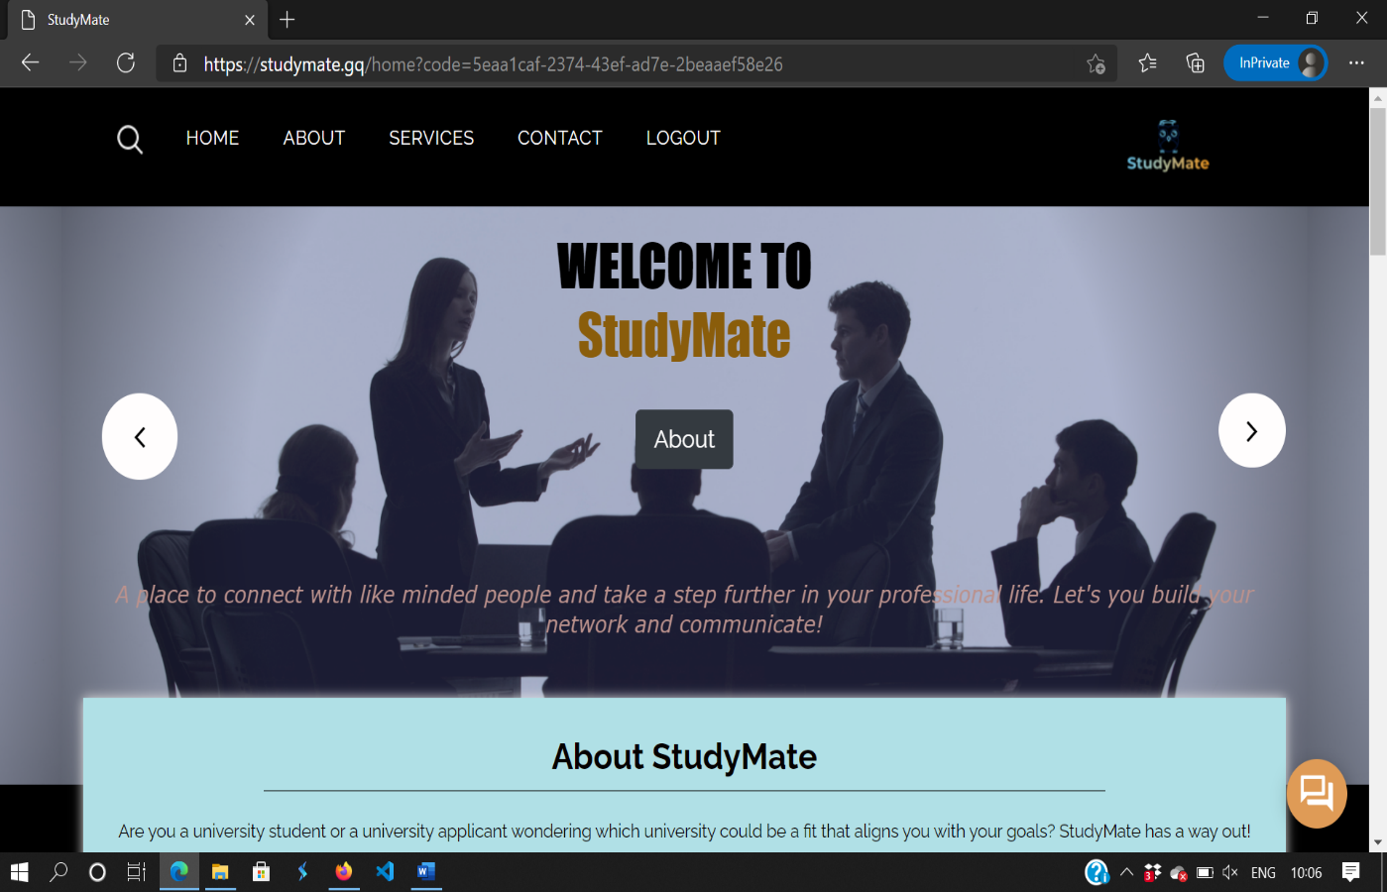

1. You can see a “LOGOUT” link and a code on your url which is your unique access code, After this you can access all the features.

Update Profile Feature :

1. Click on “Update Profile” Button from the “What We Offer” section.

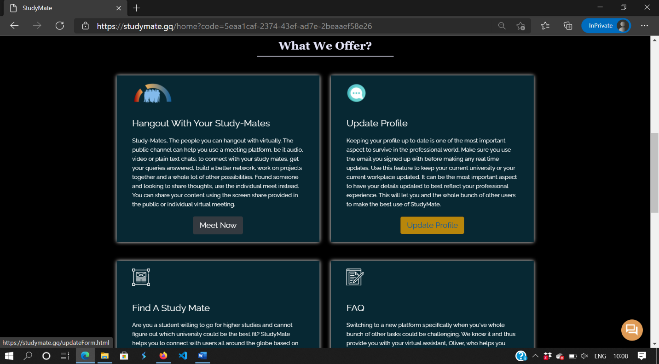

1. Enter your details to be updated in the field provide and click on “Submit” button.

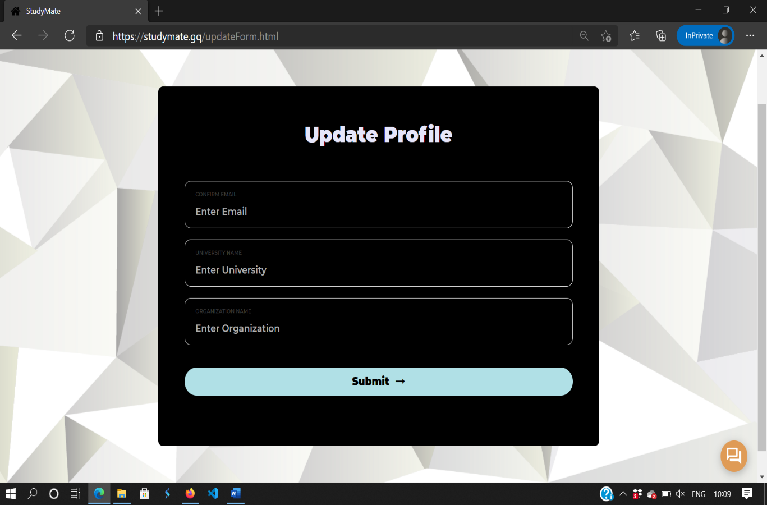

1. You’ll be redirected to your home screen again and your details are updated real time.

Find A Study Mate Feature :

1. To access the “Find A Study Mate Feature” and click on “Search” Button from “What we offer” section.

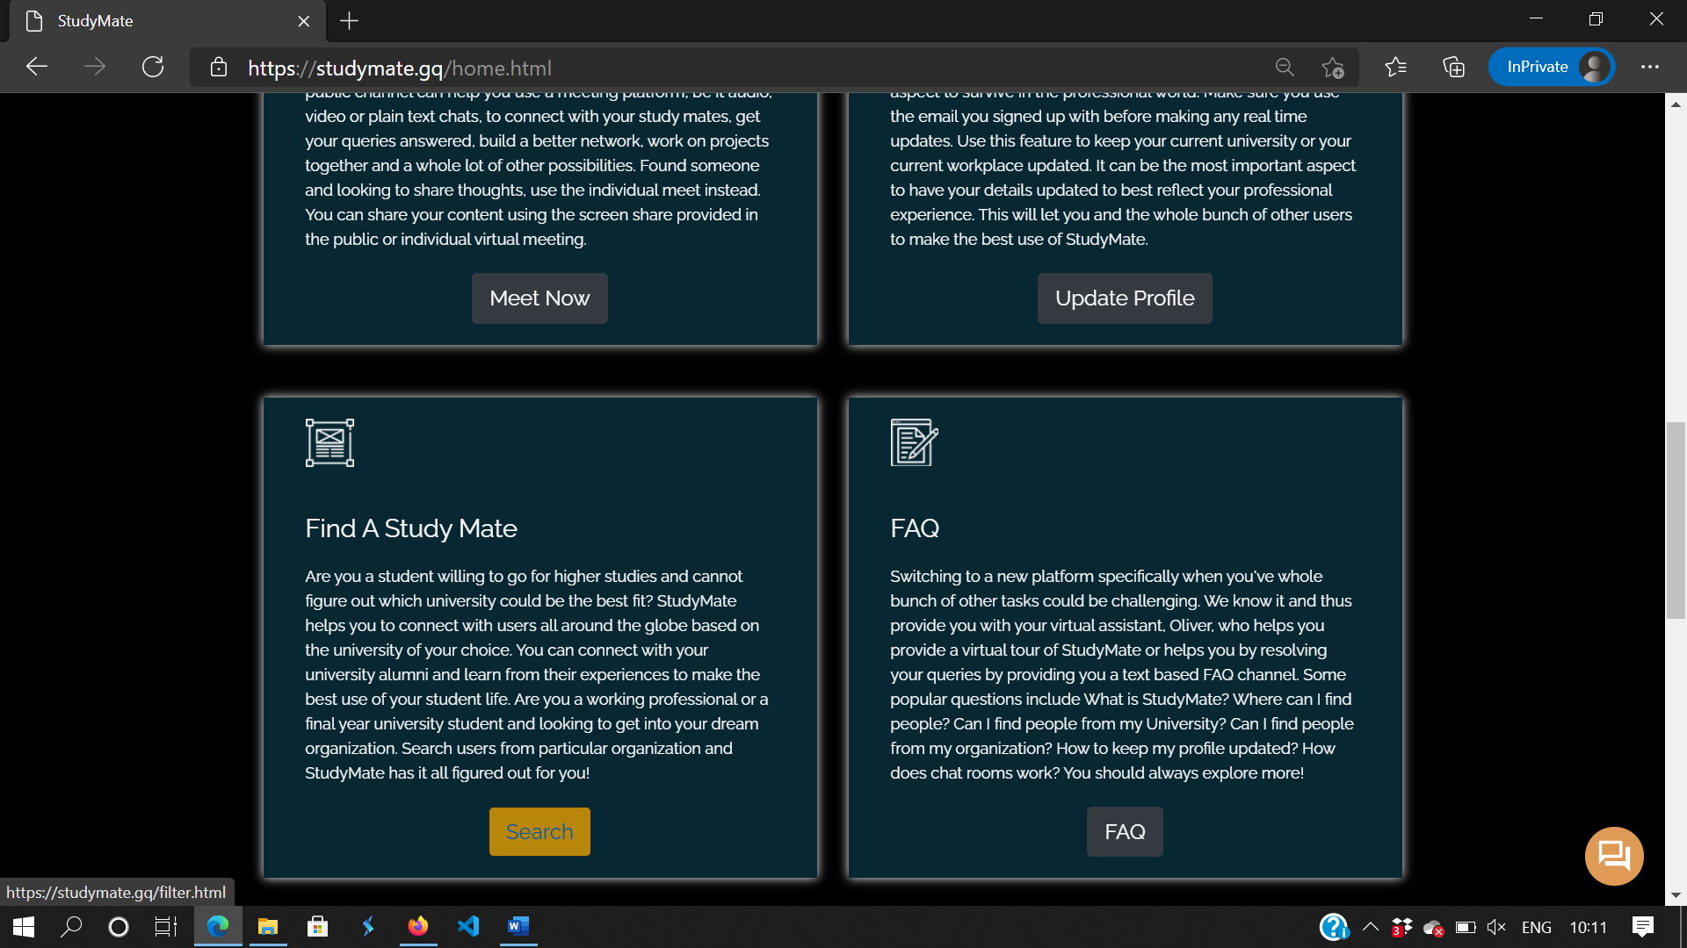

1. You’ll be redirected to our Filter page. Enter your search in “Type Keywords” Field and choose the Criteria as “University” or “Organization” from the DropDown and then click on “Search” button.

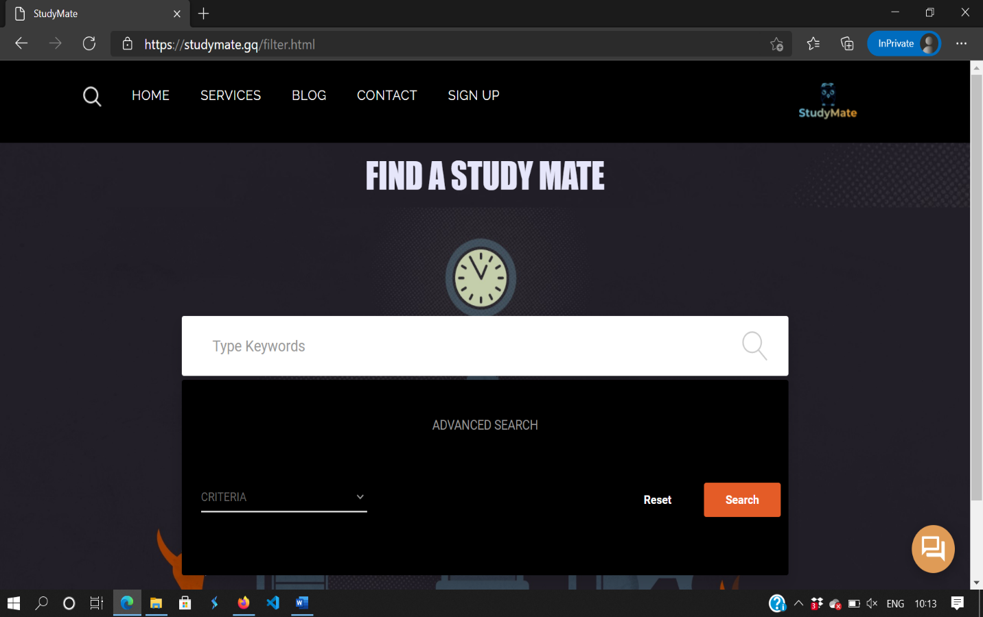

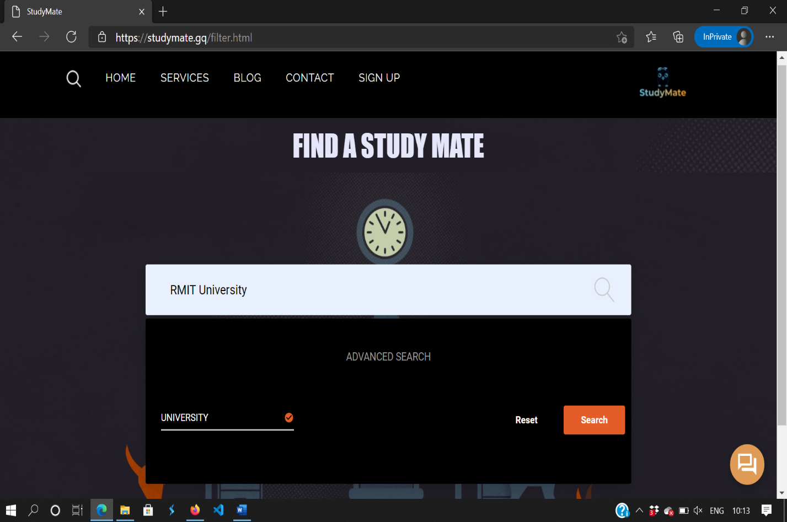

1. You’ll be now redirected to our search results which displays all the details of users based on the university or organization you searched for

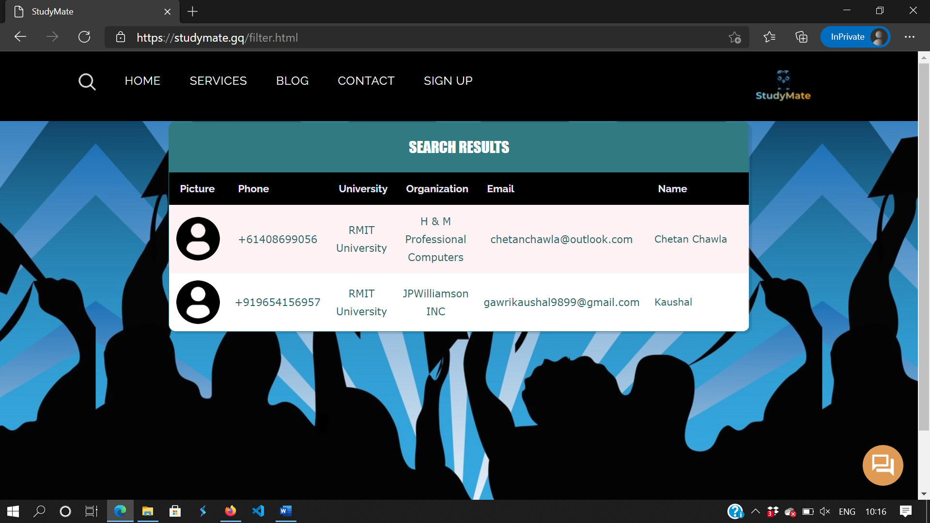

FAQ Feature:

1. To access the FAQ page, again go back to home page and from the “What we Offer” section, click on “FAQ” button

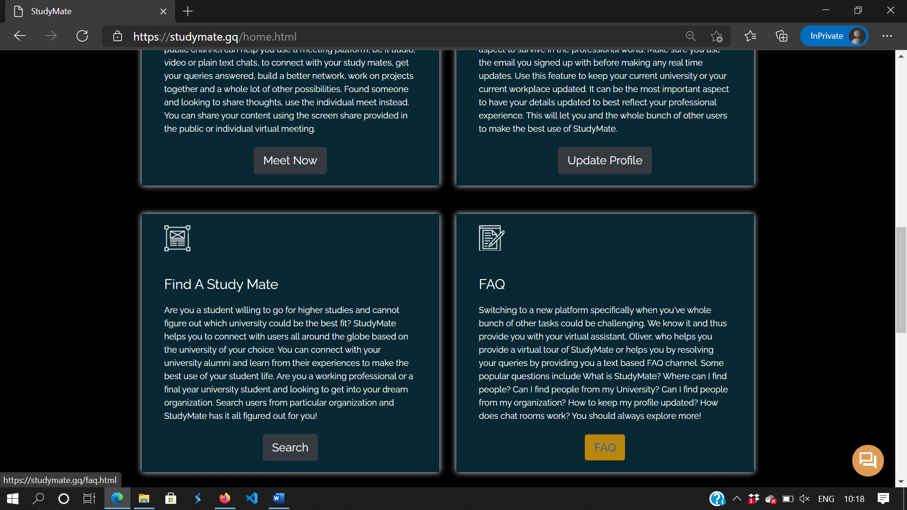

1. You’ll be redirected to our FAQ page answering some of the commonly asked questions.

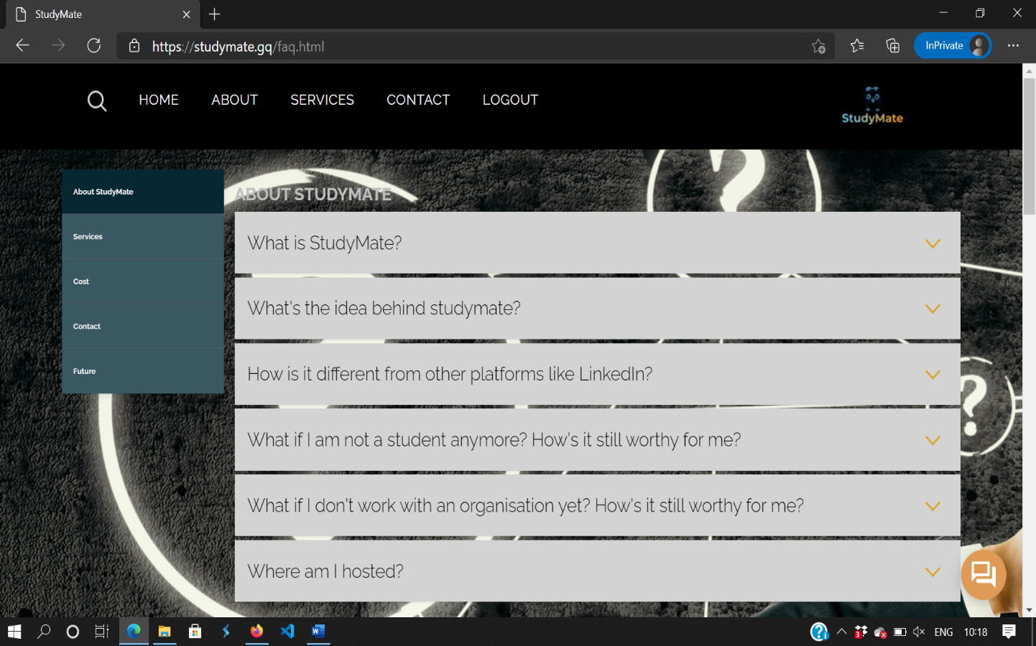

Using our FAQ Bot - Oliver:

1. You can click on the small “chat like” orange color button provided on every page of our website.

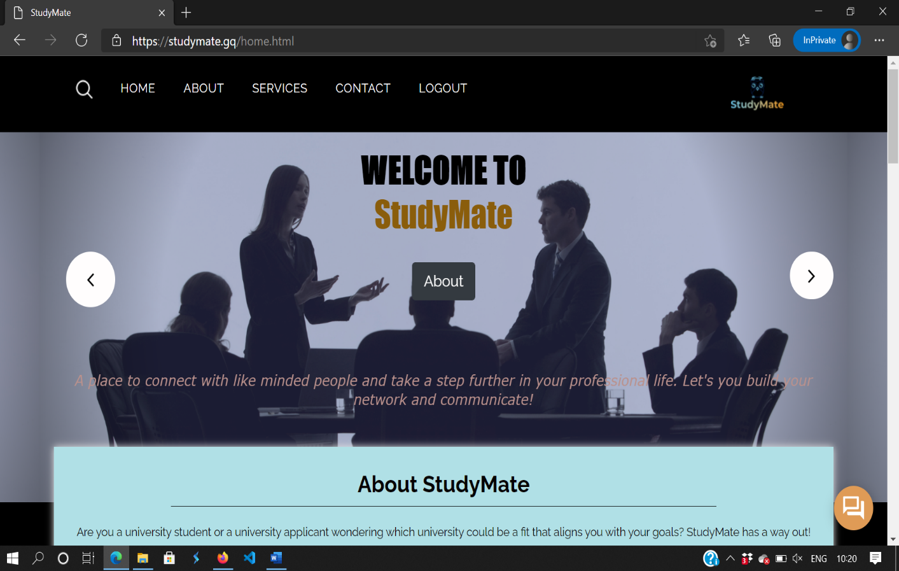

1. A chat box to clear your queries with your virtual assistant, Oliver, will appear.

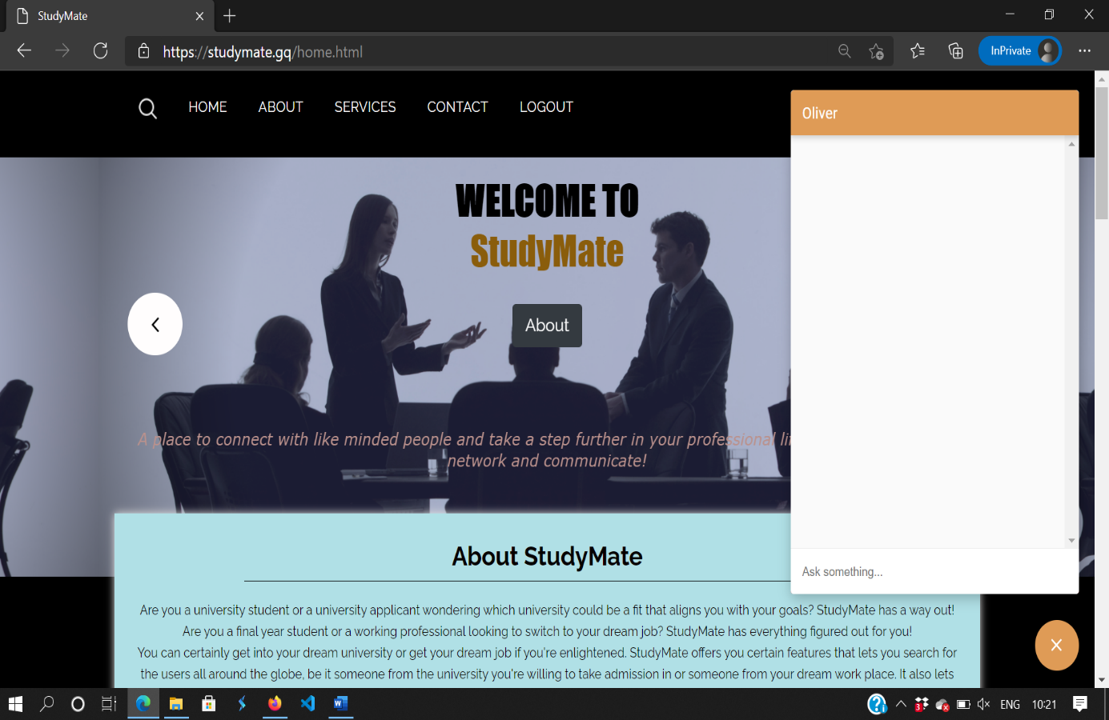

1. That’s all, you can send in your queries and our bot will try best to clear them. Else, you can also go to our FAQ section to see already resolved queries or Contact Us!

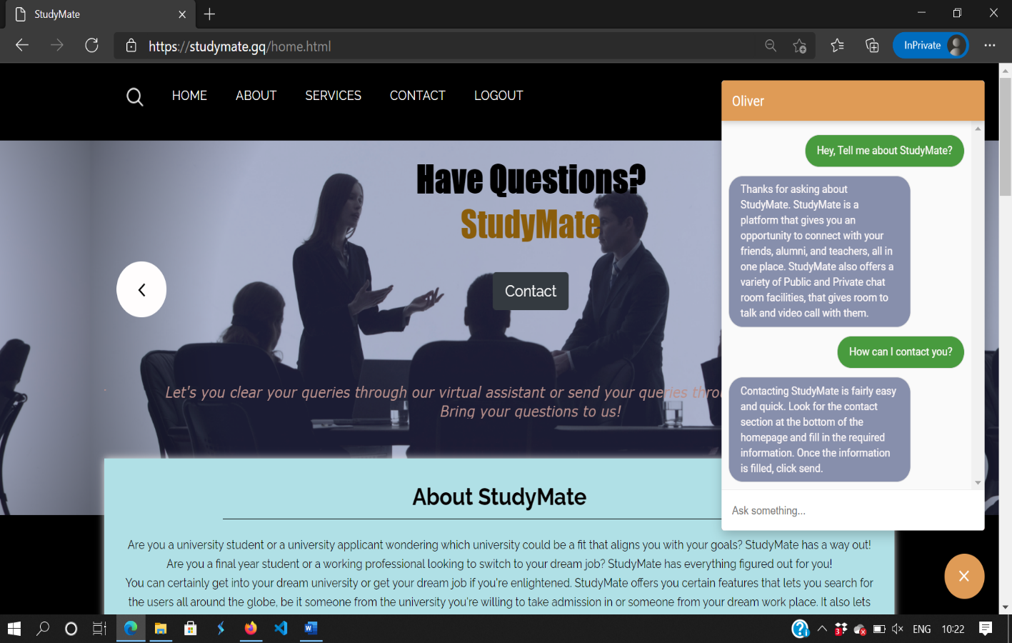

# RESPONSIVE DESIGN

StudyMate offers a fully responsive design, i.e, you can access our web app on multiple device with a great looking UI to improve the user experience. Some of the screenshots for similar features on a mobile device are added below :

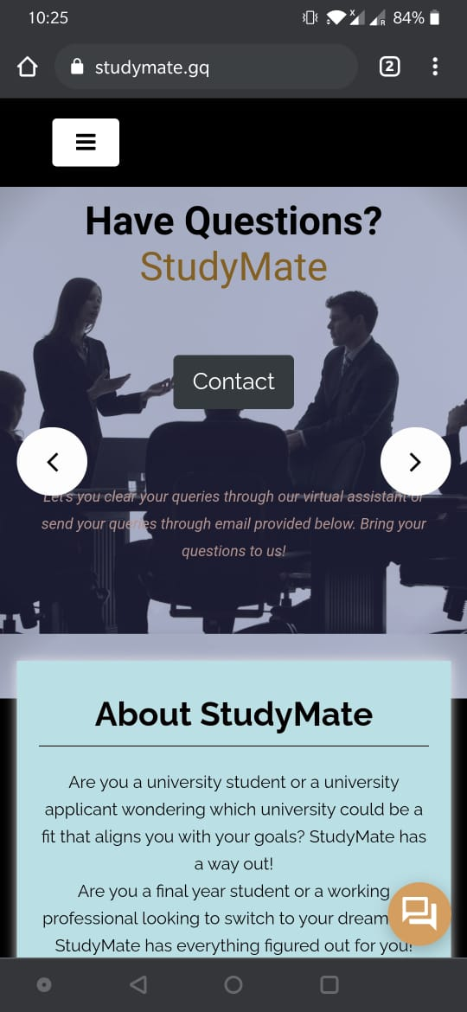 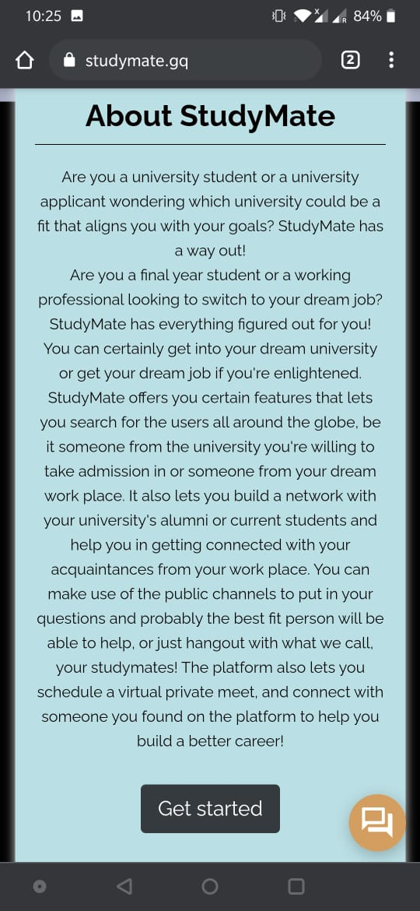 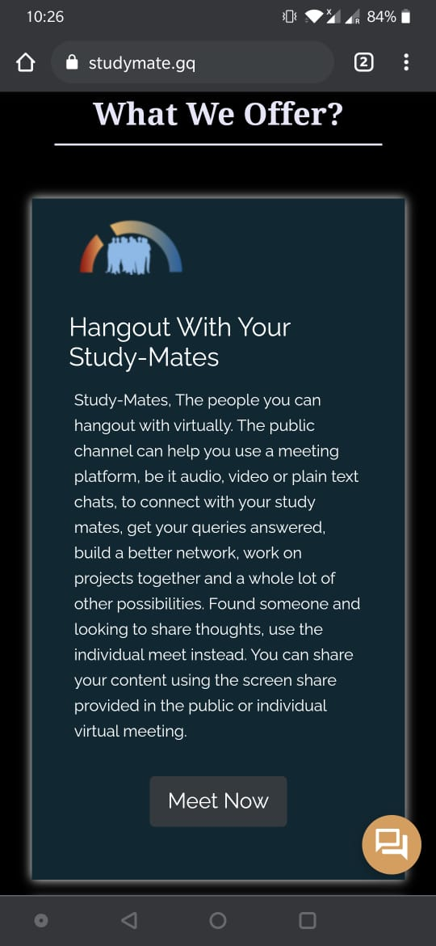

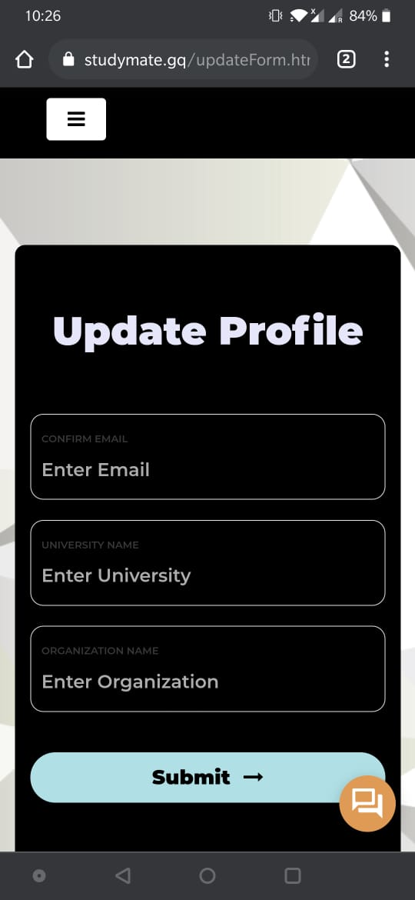 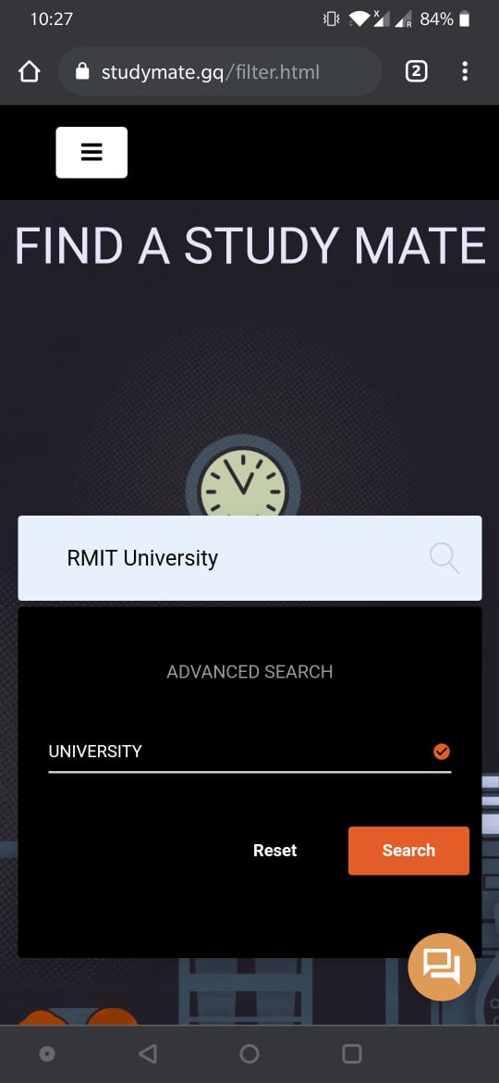 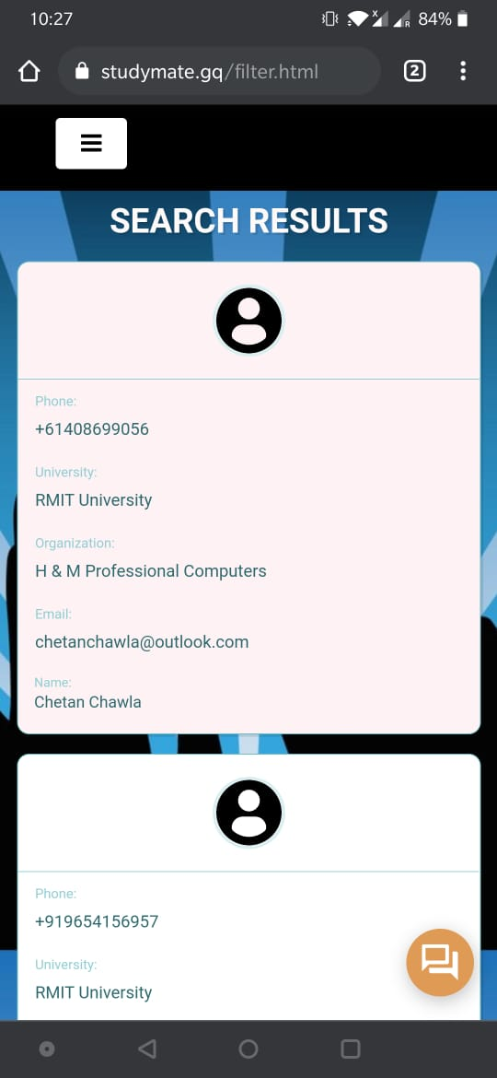

# Oliver - Chatbot using Google Dialogflow.

Dialogflow is a natural language processing (NLP) platform, which is used to create chatbots and conversational apps to improve the customer experience. This is a google powered service, which is widely used in the market and known for it exception AI understanding. We implemented Diagflow to solve the basic but most important need, frequently asked question. We all always have question but do not find anyone to answer or search on google, but here the bot always remains active like an agent with you all the time while browsing, and if you have any question regarding StudyMate, just ask the virtual agent.

The process to create Dialogflow is fairly easy and quick. First you need to create the intent, that is the user questions and the more variants of user question there will be, the better the bot will perform and guess. Second is Route, where we will route the intent with an agent reply. In route, we can specify as many replies for the same question as we want.

## Implementation

1. Login to your GCP account and search Dialog flow CX. Click enable API to start working on the service.
2. Once started, create a project or you can pick a template.

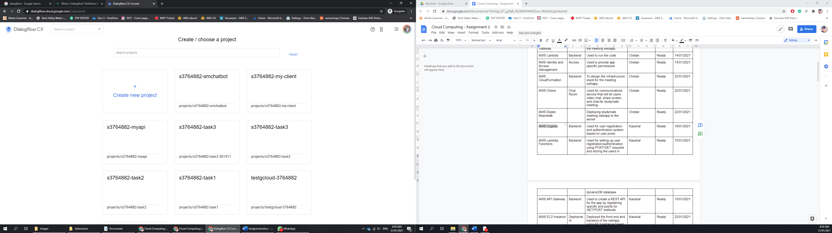

1. Create a genet by clicking on Create Agent, that will be your virtual assistant.

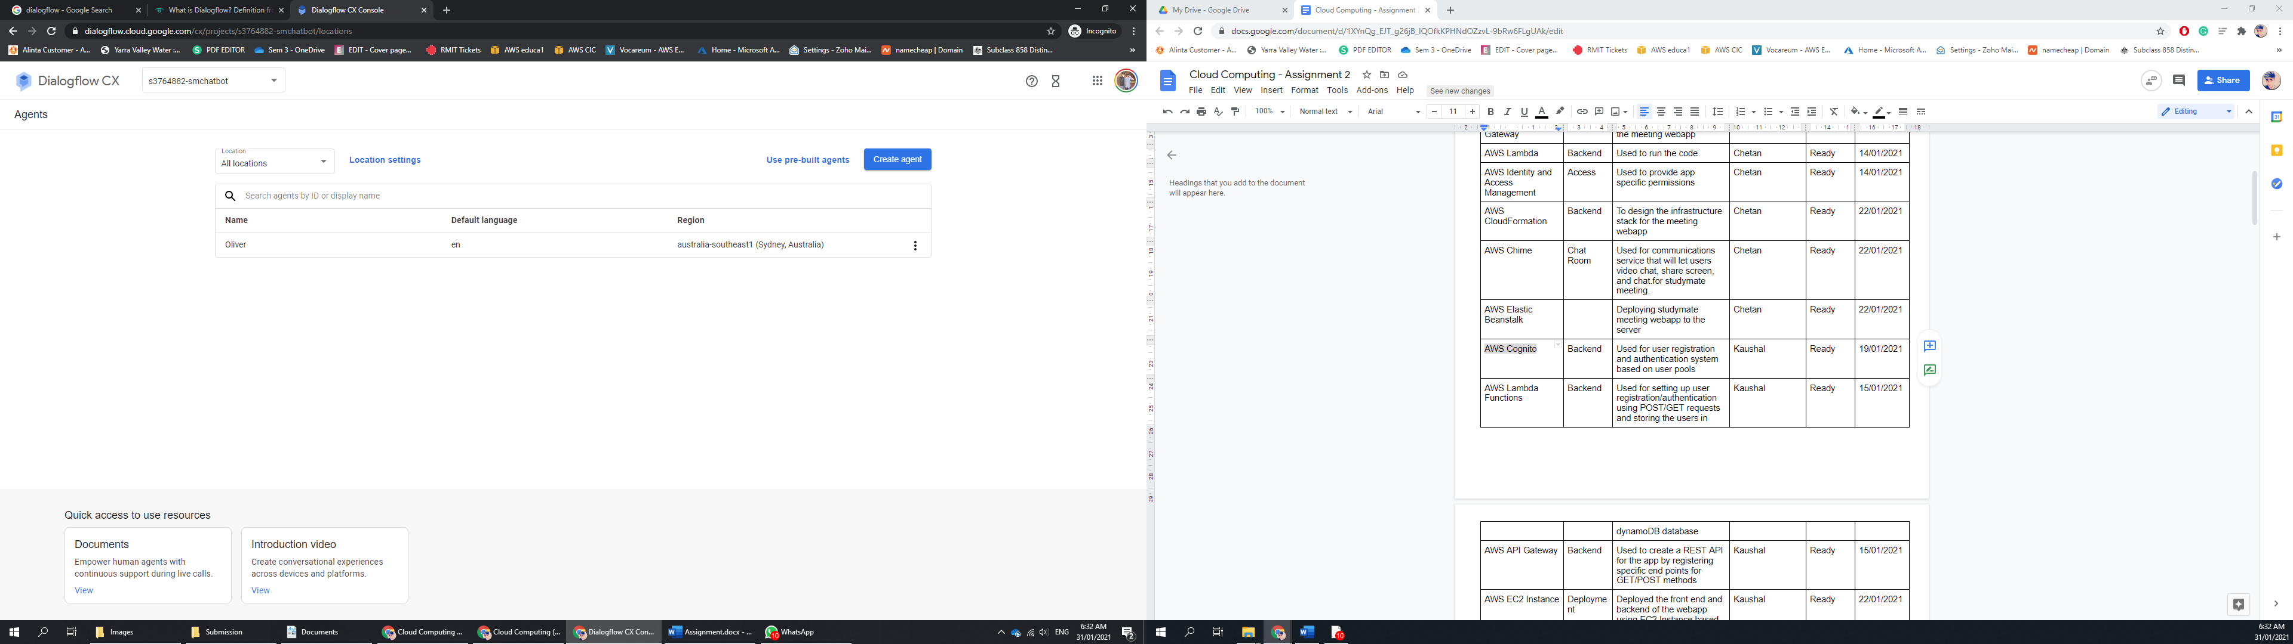

1. Once created, click on the manage tab and then intent from resources to start creating intents.

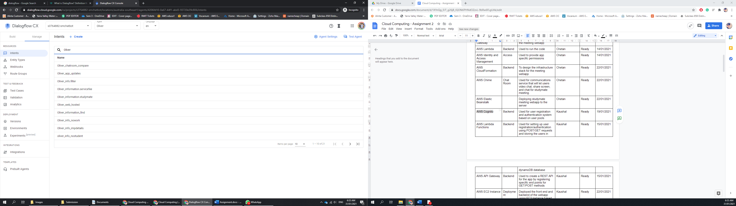

1. Now go back to the home page of Dialogflow and click on “+” beside Route to define the agent reply.

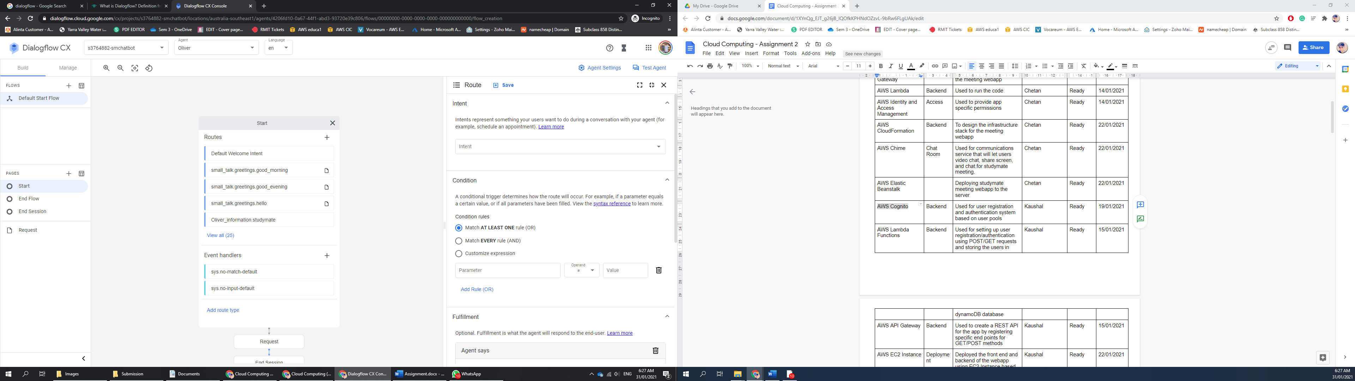

1. Now choose the intent and specify the condition if there’s any, otherwise leave default and move to fulfilment. Type the agent reply in “Agent Says” and click save on the top.



# FAQ Questions

### What is StudyMate?

Thanks for asking about StudyMate. StudyMate is a platform that gives you an opportunity to connect with your friends, alumni, and teachers, all in one place. StudyMate also offers a variety of Public and Private chat room facilities, that gives room to talk and video call with them.

### What's the idea behind studymate?

StudyMate is a platform that gives you an opportunity to connect with your friends, alumni, and teachers, all in one place. StudyMate also offers a variety of Public and Private chat room facilities, that gives room to talk and video call with them.

### What do we offer? What does StudyMate provide?

StudyMate offers a couple of services that helps you stay connected with your mates. From finding your mates with the help of a filter page, to chatting with them using the private and public chat rooms. Browse through the service page on the home page to stay updated about the services that we offer.

### How is it different from other platforms like LinkedIn?

StudyMate is the only app at the moment that lets you find your mate through a search or among a bunch of other people in a public chat room. You can work together in a team and use features such as screen share, video share and many more.

### Where can I find people?

You can find people using the Find A Study Mate section on the home screen. You can filter either with university or organisation and look for people.

### How does a public chat room work?

Public chat rooms are open chat rooms that let you join the chat room with a bunch of other people and talk with them. This is one amazing feature that helps in making new friends online.

### Is studymate free? Is the chatroom service free? Are there any premium accounts?

StudyMate is a completely free service for it’s users. We at StudyMate don't charge for any of the services offered or listed on the website, www.studymate.gq.

### How can I contact StudyMate?

Contacting StudyMate is fairly easy and quick. Look for the contact section at the bottom of the homepage and fill in the required information. Once the information is filled, click send.

### How can I hangout with my mates?

StudyMate offers a variety of Public and Private chat room facilities that give you a room to talk and video call with them.

### Is there an option for a private meeting? Individual meeting?

StudyMate offers Private chat room facilities that give you a room to talk and video call with them. You can also share your screen or videos in the same room.

### How does this filter work?

Filter, let you search people from universities and organisations. You can find people using the Find A Study Mate section on the home screen. You can filter either with university or organisation and look for people.

### How can I change my details?

Changing your details is fairly easy and simple. First sign in into your account and browse to the Change Details section. You will be redirected to the profile page and there you can update all your information.

### Do I need to provide both University or Organisation name while updating my details?

No, It is not a requirement to provide both. Keeping your profile updated and filling all the information lets your mates search you more easily.

### What if I don't work with an organisation yet? How's it still worthy for me?

That is alright. You can still find mates from your university or use the public chat room to explore the new opportunities in the job world.

### What if I am not a student anymore? How's it still worthy for me?

It is alright if you’re not a student anymore. You can stay connected with your old mates and keep yourself updated.

### Is there a way to contact people without making the use of their phone number/email?

Using the public chat room service, you can contact other people without emailing or calling them.

### How does chat rooms work?

StudyMate Chat Rooms is one of the powerful and responsive chat rooms that uses Amazon Chime API. We at StudyMate keep our services up-to-date to make an amazing experience for you and your mates.

### How are chat rooms different from apps like zoom or teams?

Zoom and Teams does not offer public chat room services, that makes us different from other such apps. We not only offer public chat rooms but also offer you to find your mates from your university or organisation that zoom and team doesn't offer.

### What can we expect from studymate in future? Can I share my thoughts with the rest of the users? Can I publish an article? Can I share my personal projects on it? How can I contribute as an individual? Is there any financial model provided? What are the future extensions to the current model?

Currently StudyMate is running on Beta and is fully operational at the moment. We at StudyMate have some crazy ideas in our mind, that we are working hard to implement and share with all of you out there. To check the new features and update. Log on to [www.studymate.gq](http://www.studymate.gq) or email us at support@studymate.gq

### Where am I hosted?

StudyMate is a secure website hosted on powerful AWS Servers.  We use SSl to encrypt all the traffic and a virtual private network to safeguard all your private information.